CLOUD COMPUTING

**PRACTICAL: 1**

**IMPLEMENTING CLUSTER ON WINDOWS**

Install the **VMWare Workstation**. The **Home page** of VMWare Workstation looks like the picture below. To create a new Virtual Machine click on **“Create a New Virtual Machine”**.

In the **“New Virtual Machine Wizard”** select the **“Typical”** option. And click on **“Next”** button.

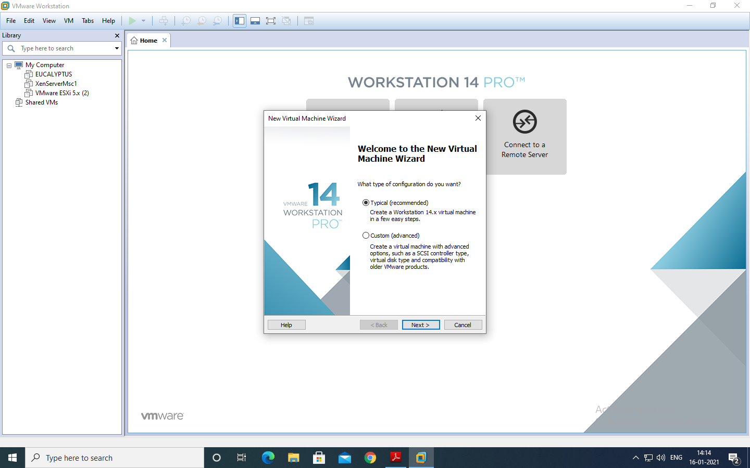

In the Next window, select the option **Install Disc** and click on **Browse** to select the windows server 2012 iso file and then click on **Next.**

In this window, select the name of **operating system** and its **version.**

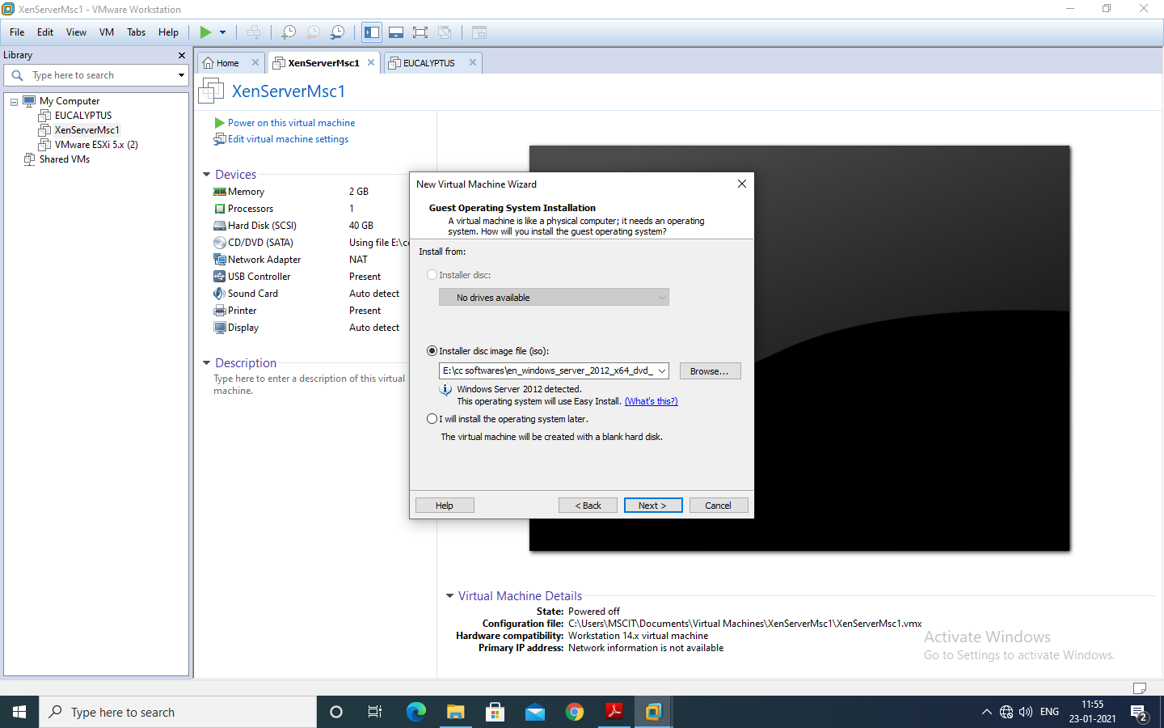

Click **“Next”,** And click on yes

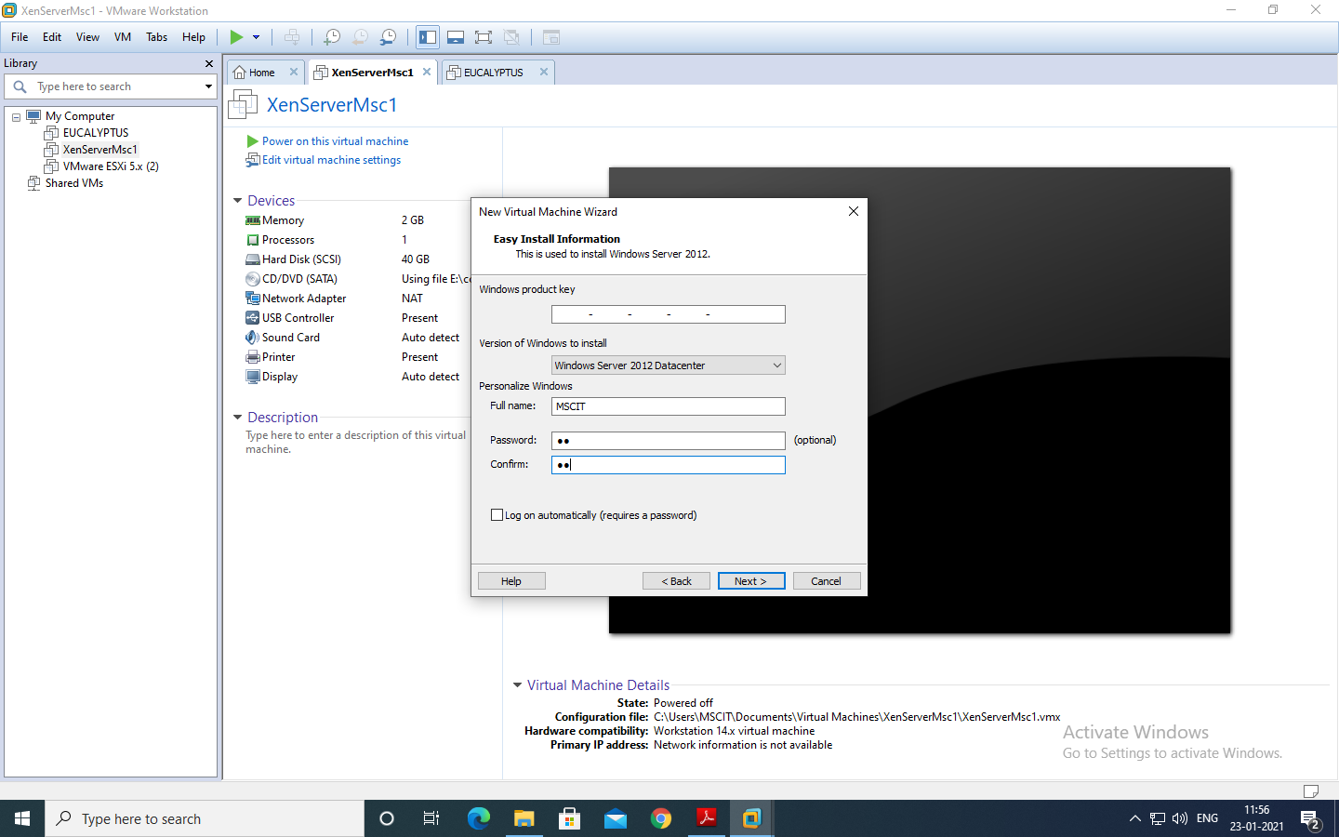

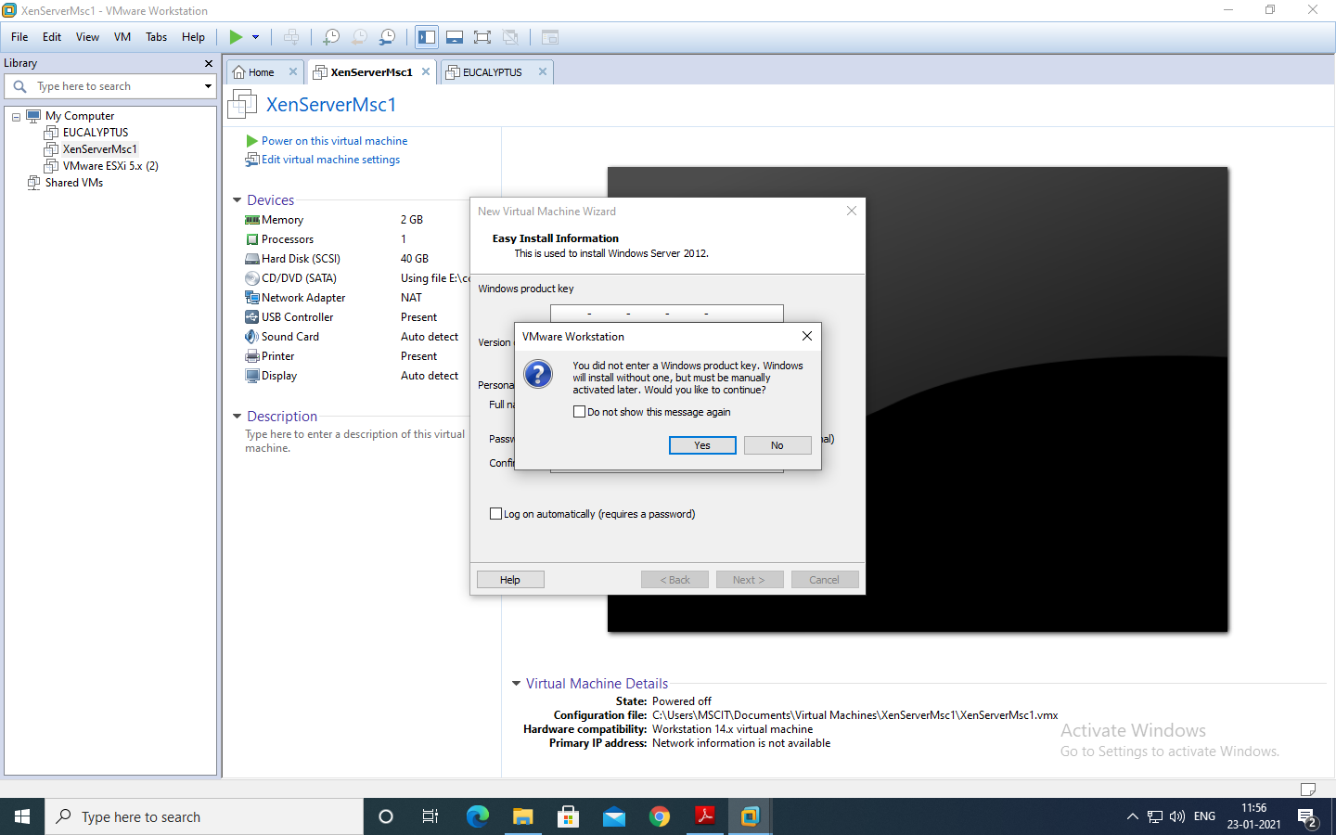

Choose **“Store virtual disk as a single file”** and Keep the memory size as **90GB**. Click on “**Next**”>>Click on “**Finish**” button.

Click on **Memory** under Devices on the right side and make it to **2GB.**

Power on the virtual machine by clicking on “**Power on this virtual machine**”.

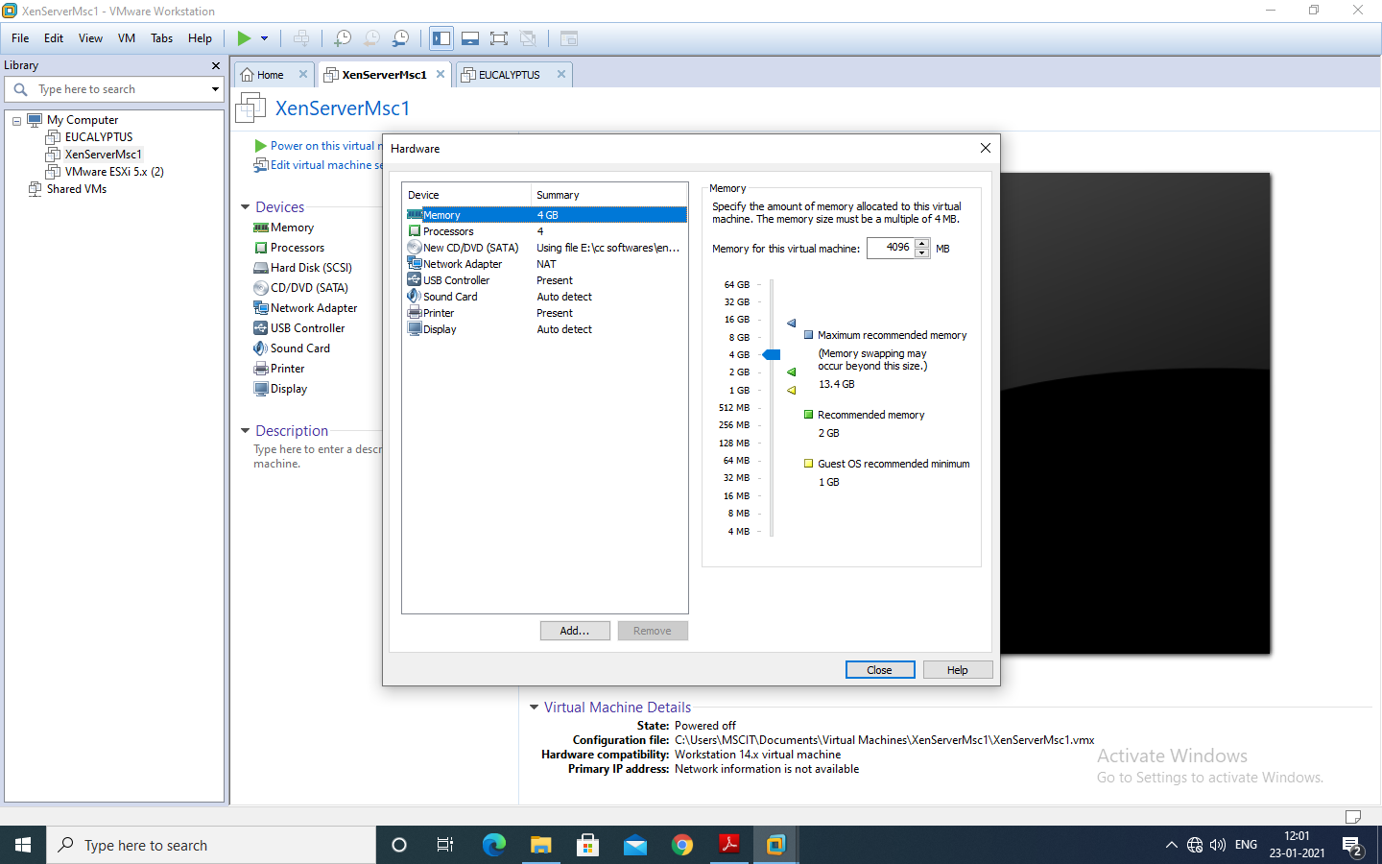

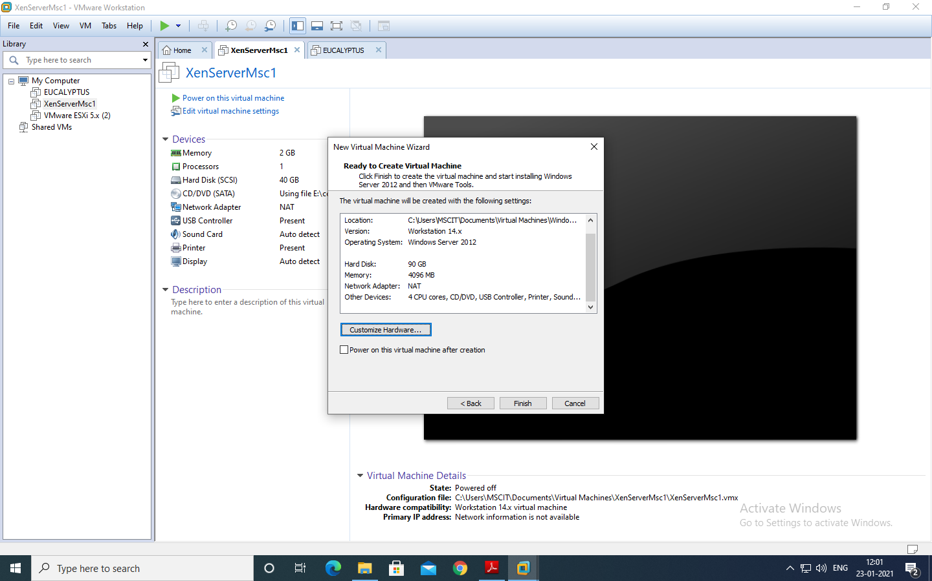

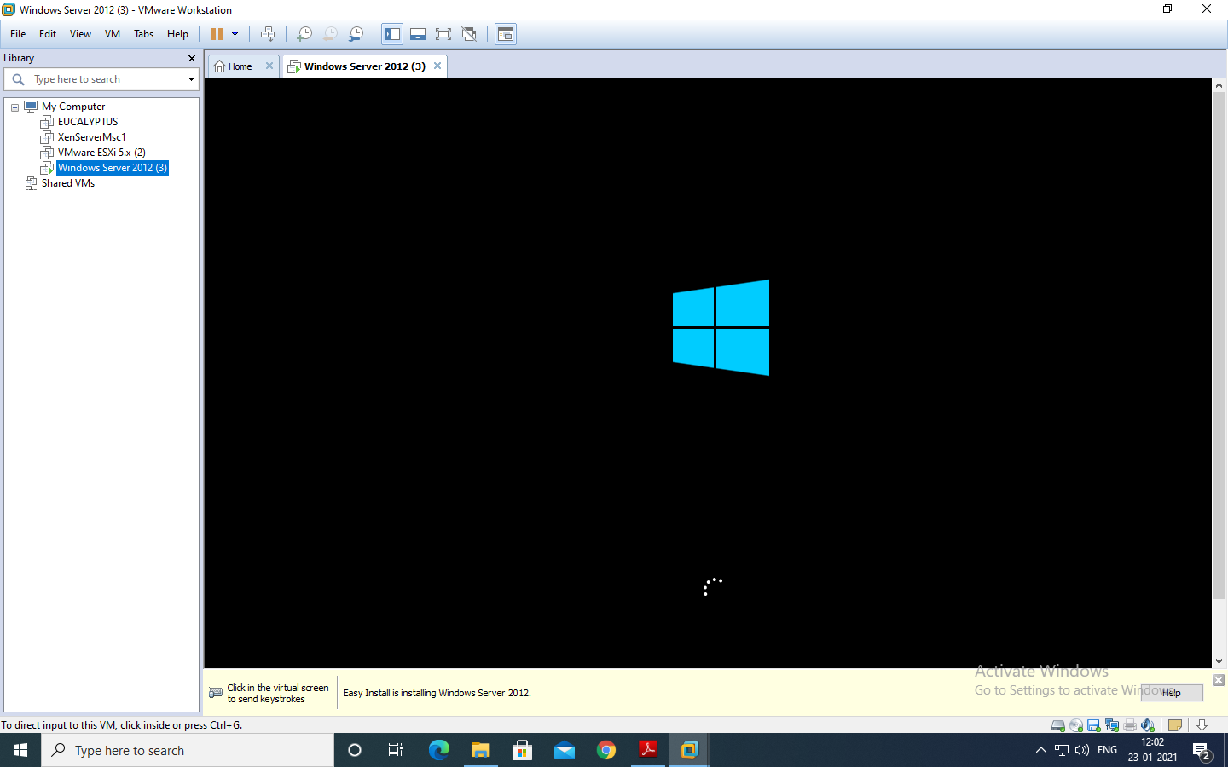

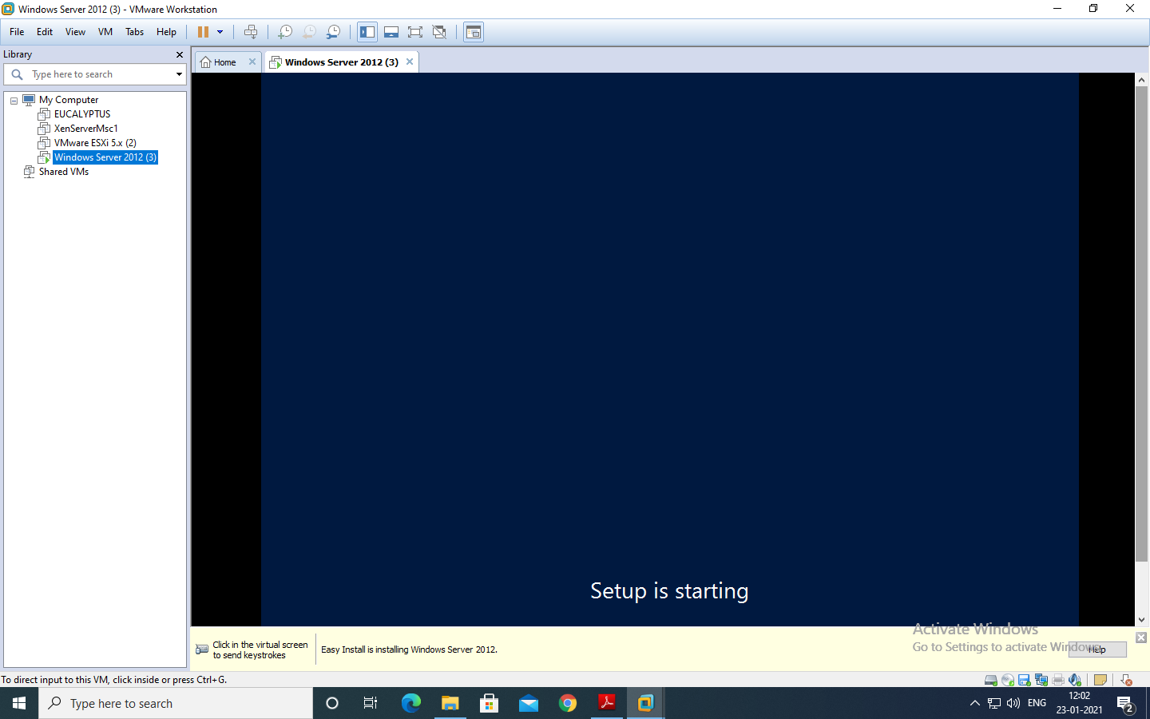

Copying of **System Files** will start.

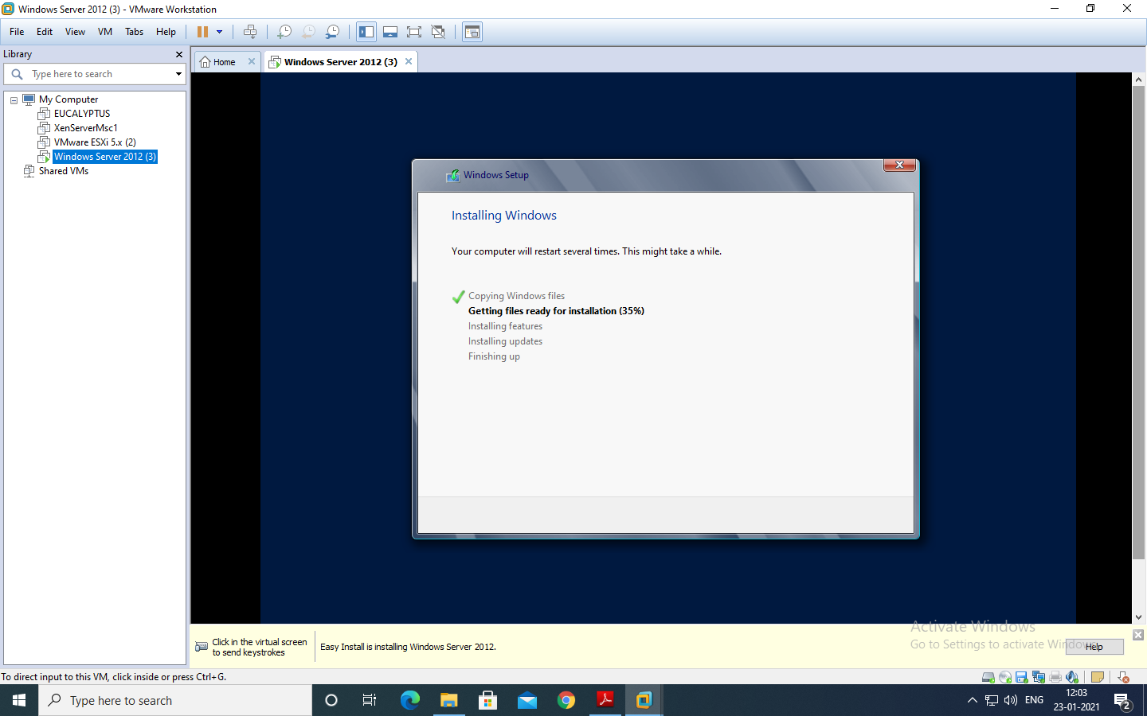

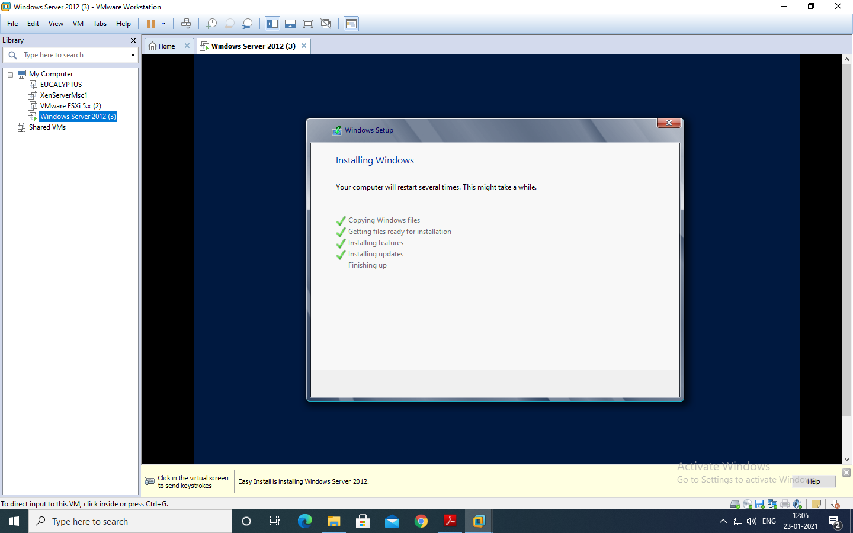

After copying files it will automatically start.

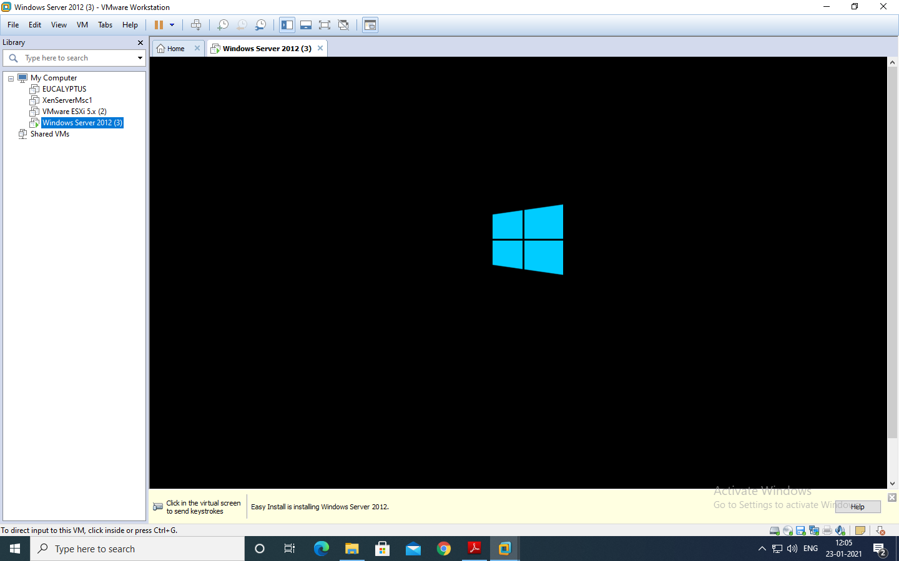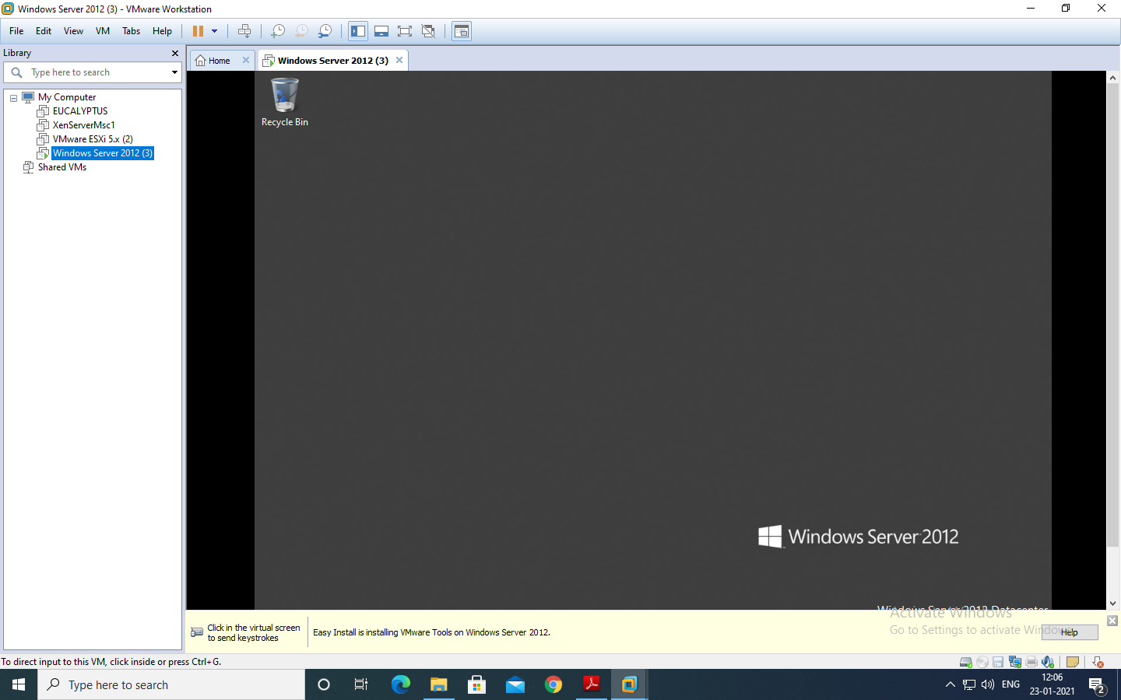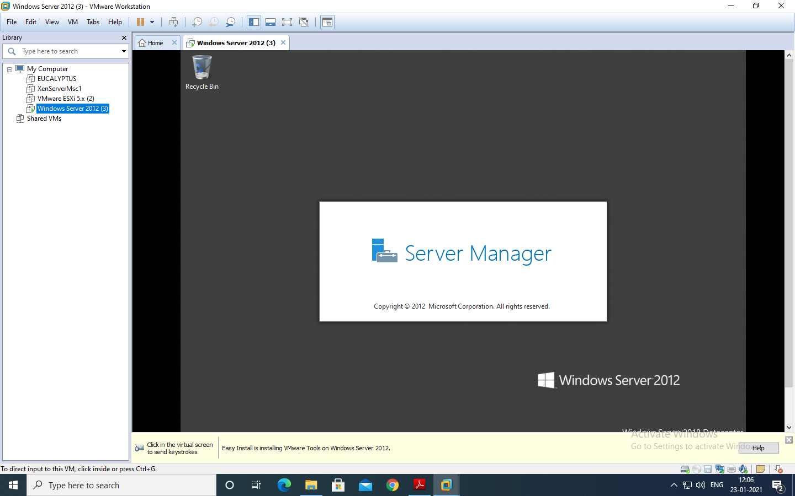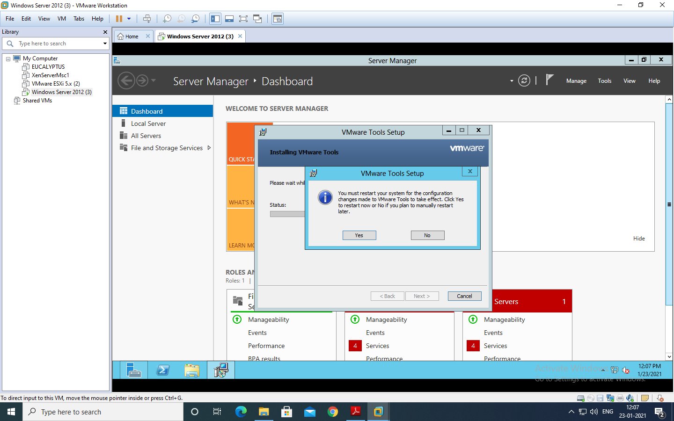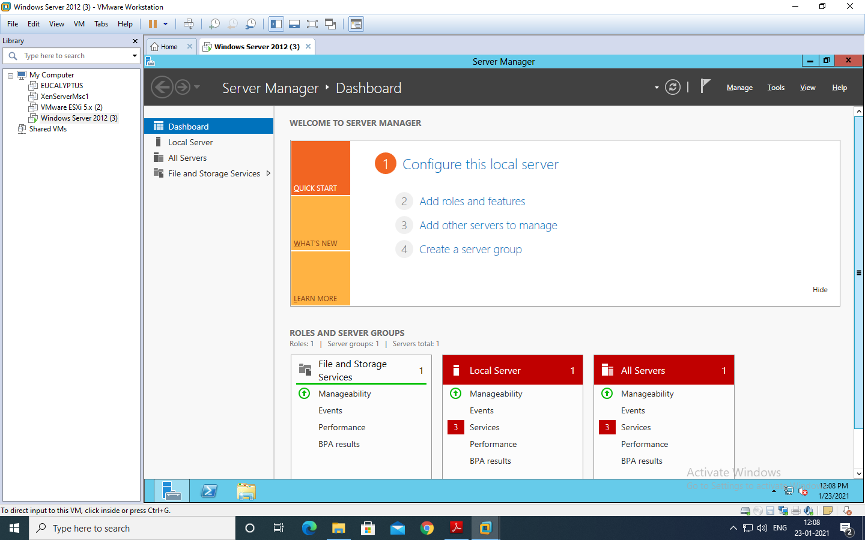

If installing on the Virtual Machine like VMWare then you need to click on the menu as show in the next screen.

Enter the password and press “Enter” button on the keyboard

Password:Admin12345 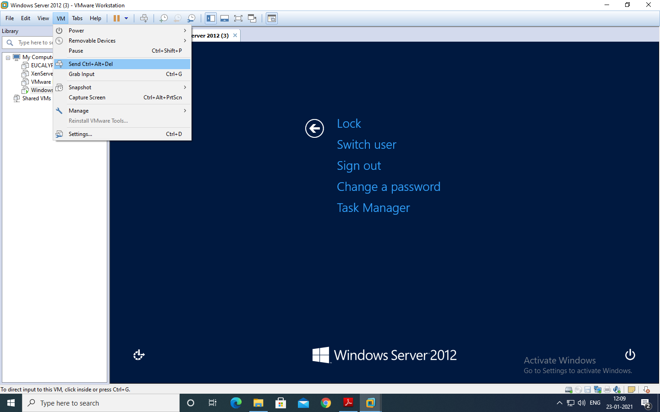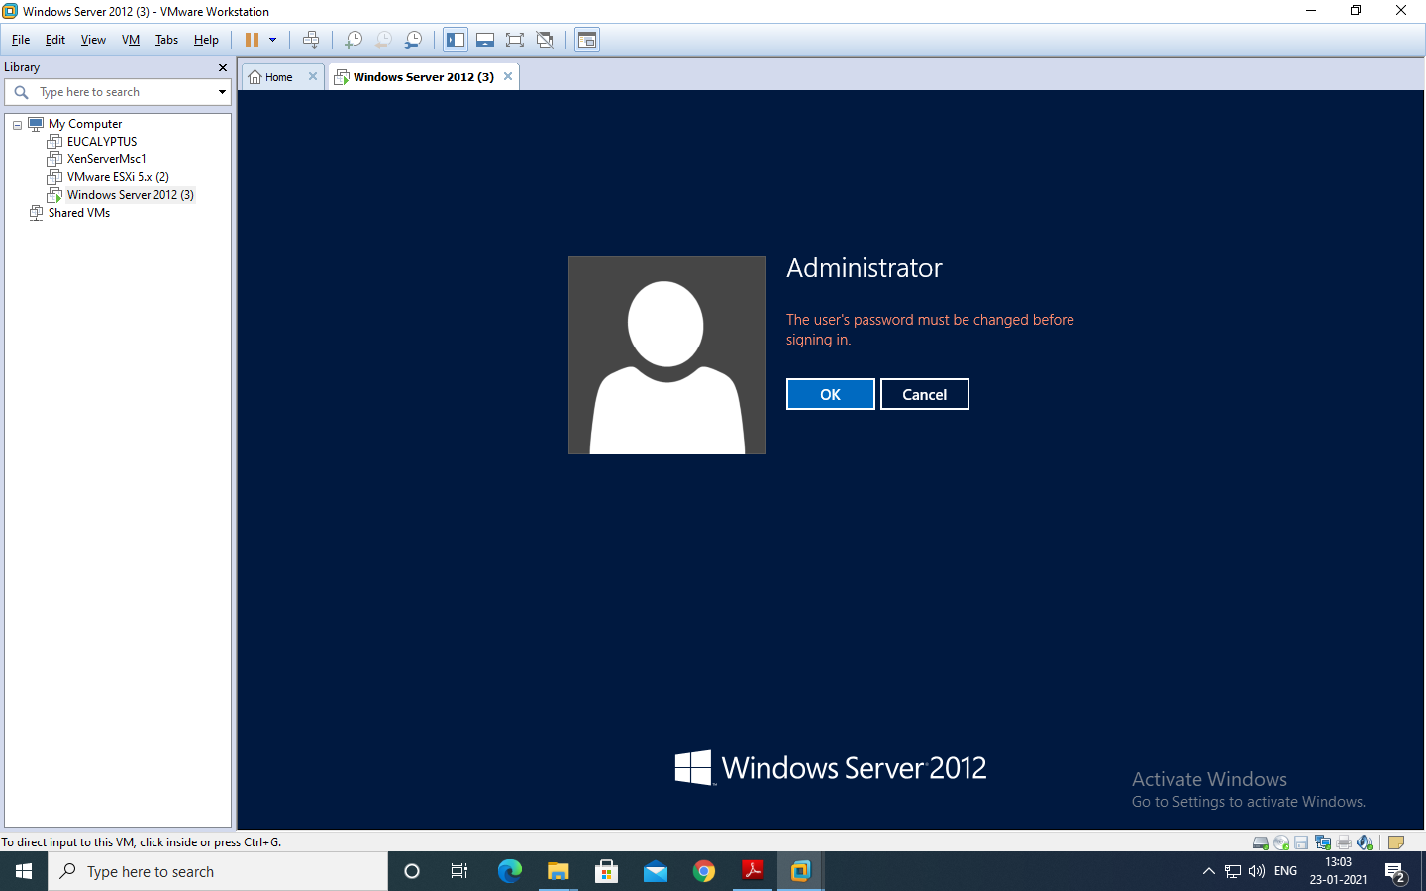

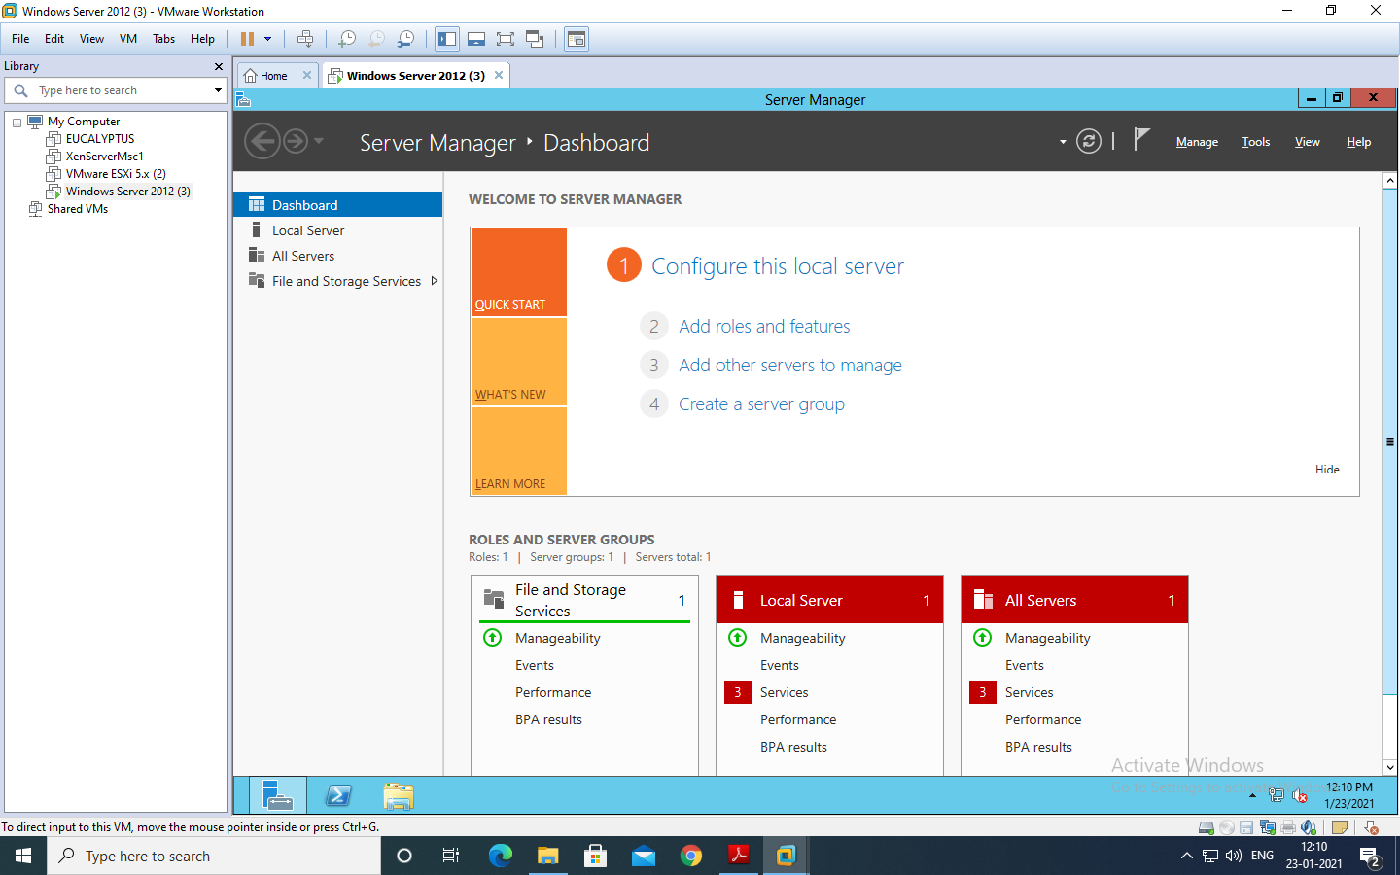

To make the current system a Domain Controller click on “Add Roles and Features” under the “Manage” menu at the top of the screen and get the “Add Roles and Feature Wizard”.

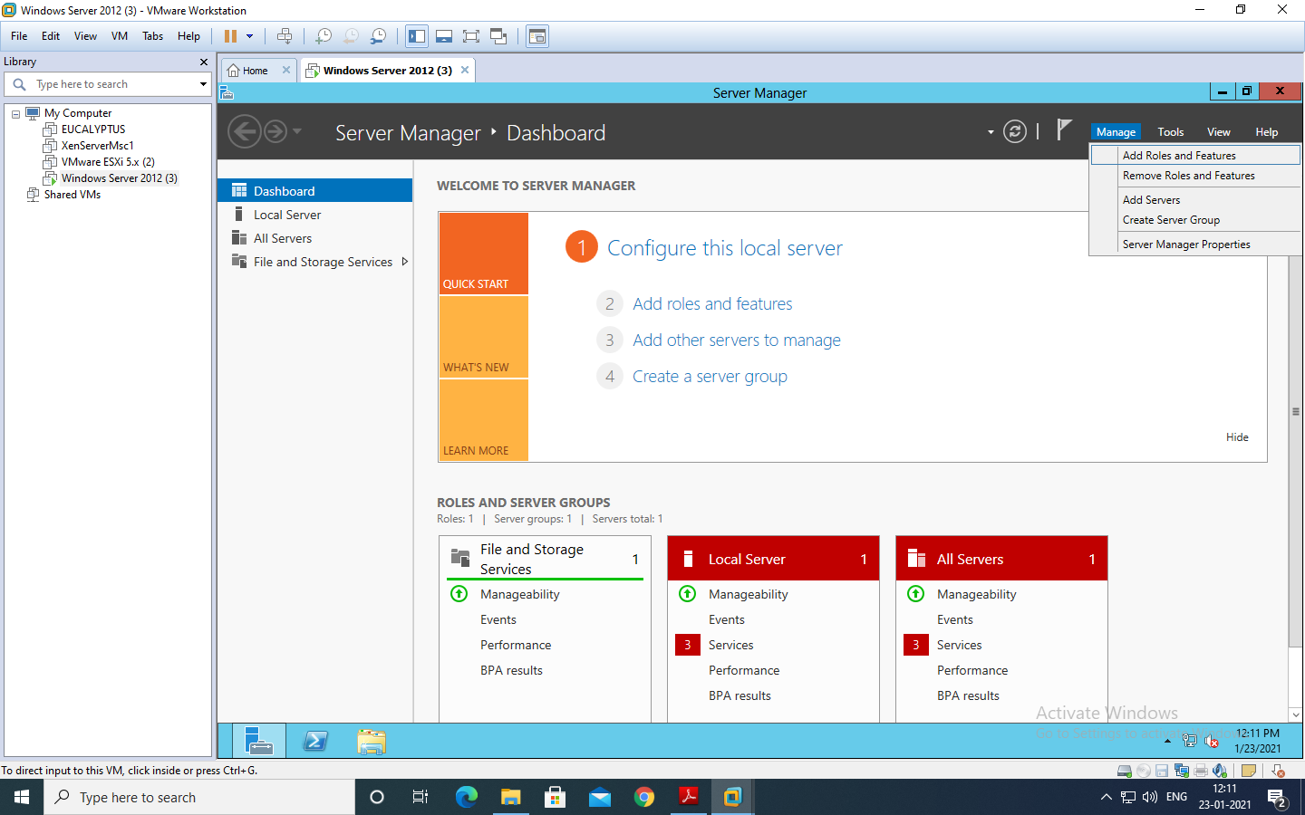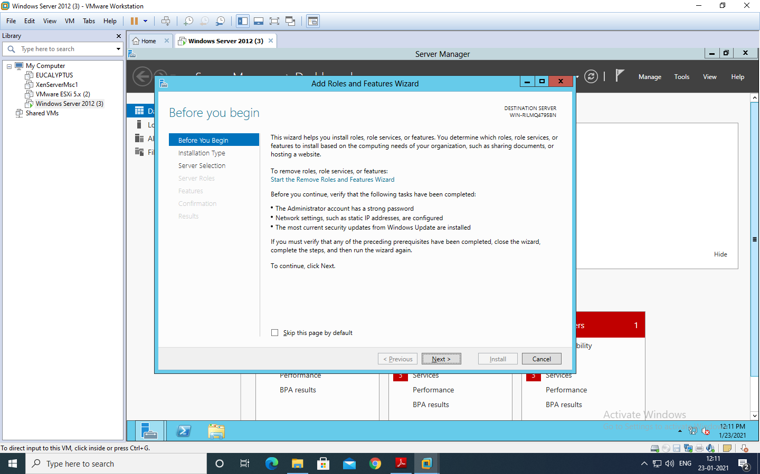

Under “select installation Type” select “Role-based or feature-based installation” and click “Next” button.

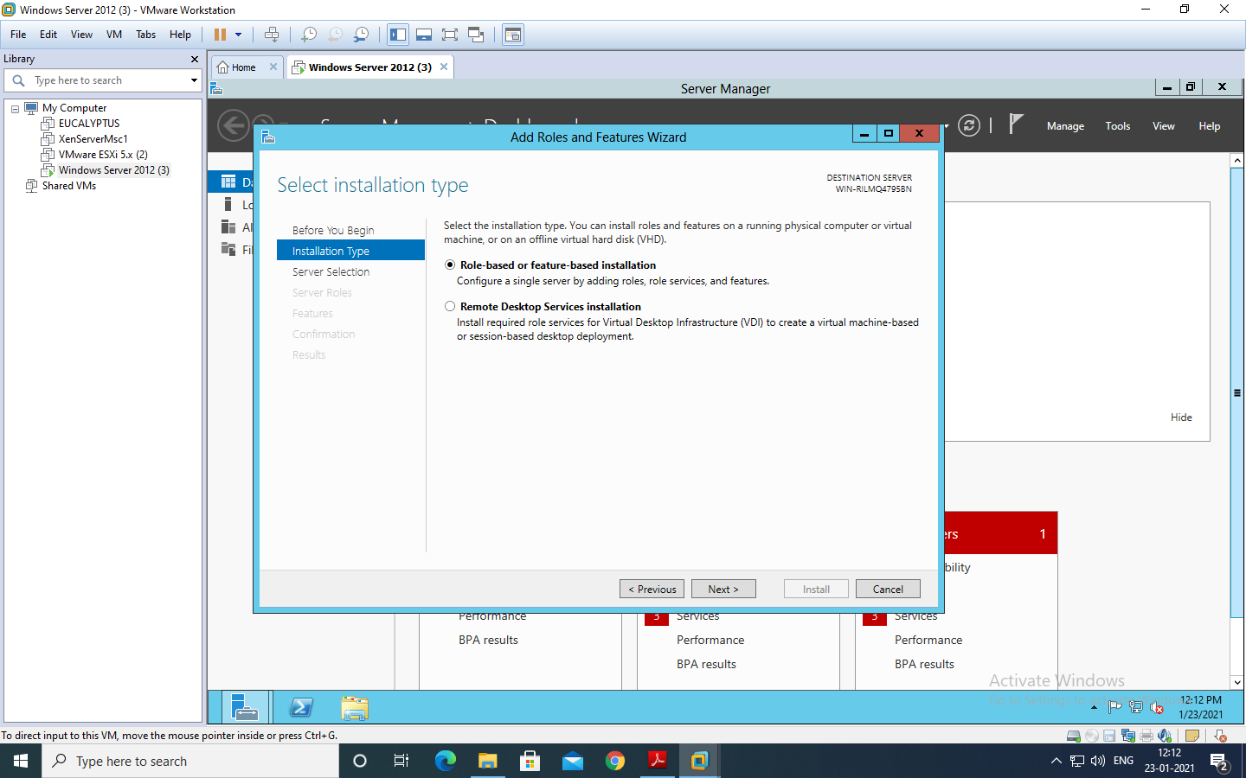

Under “select destination Server” select “Select a server from the server pool” option and select the server as shown in the screen below and click “Next”

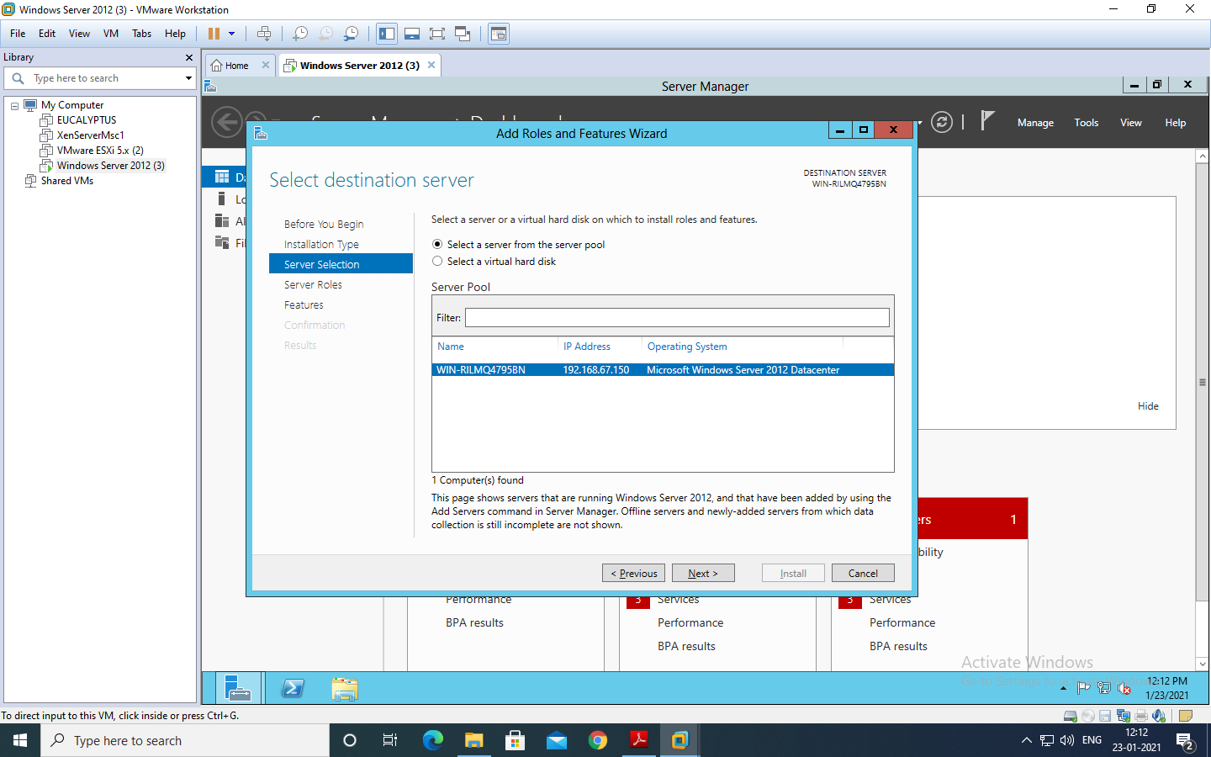

Click on “Active Directory Services”, “DNS” and “DNS” roles from the list of roles provided and click on “Add Features” button as shown in the screen. Add Features button will appear as you click on any of the roles.

After selecting the Role click “Next”.

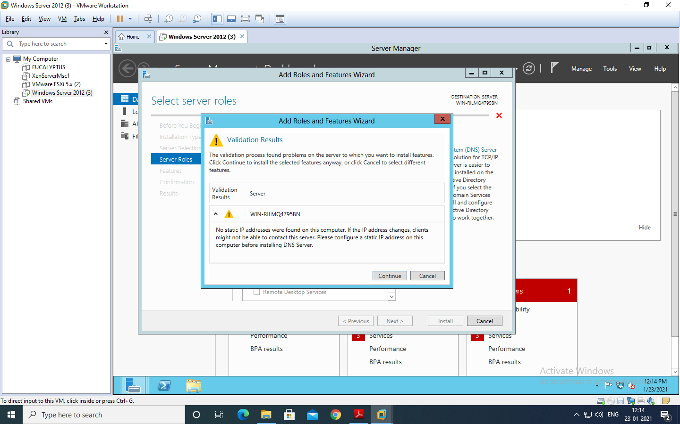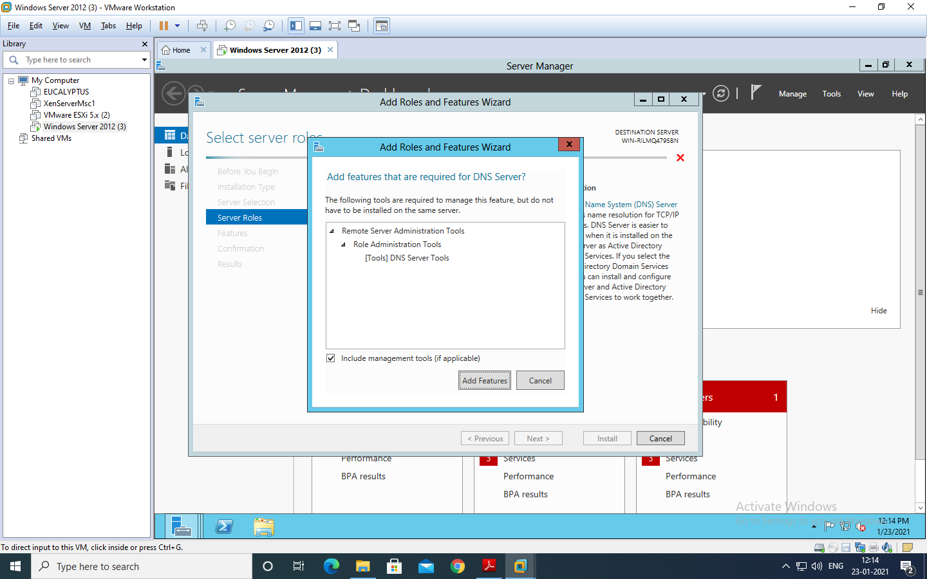

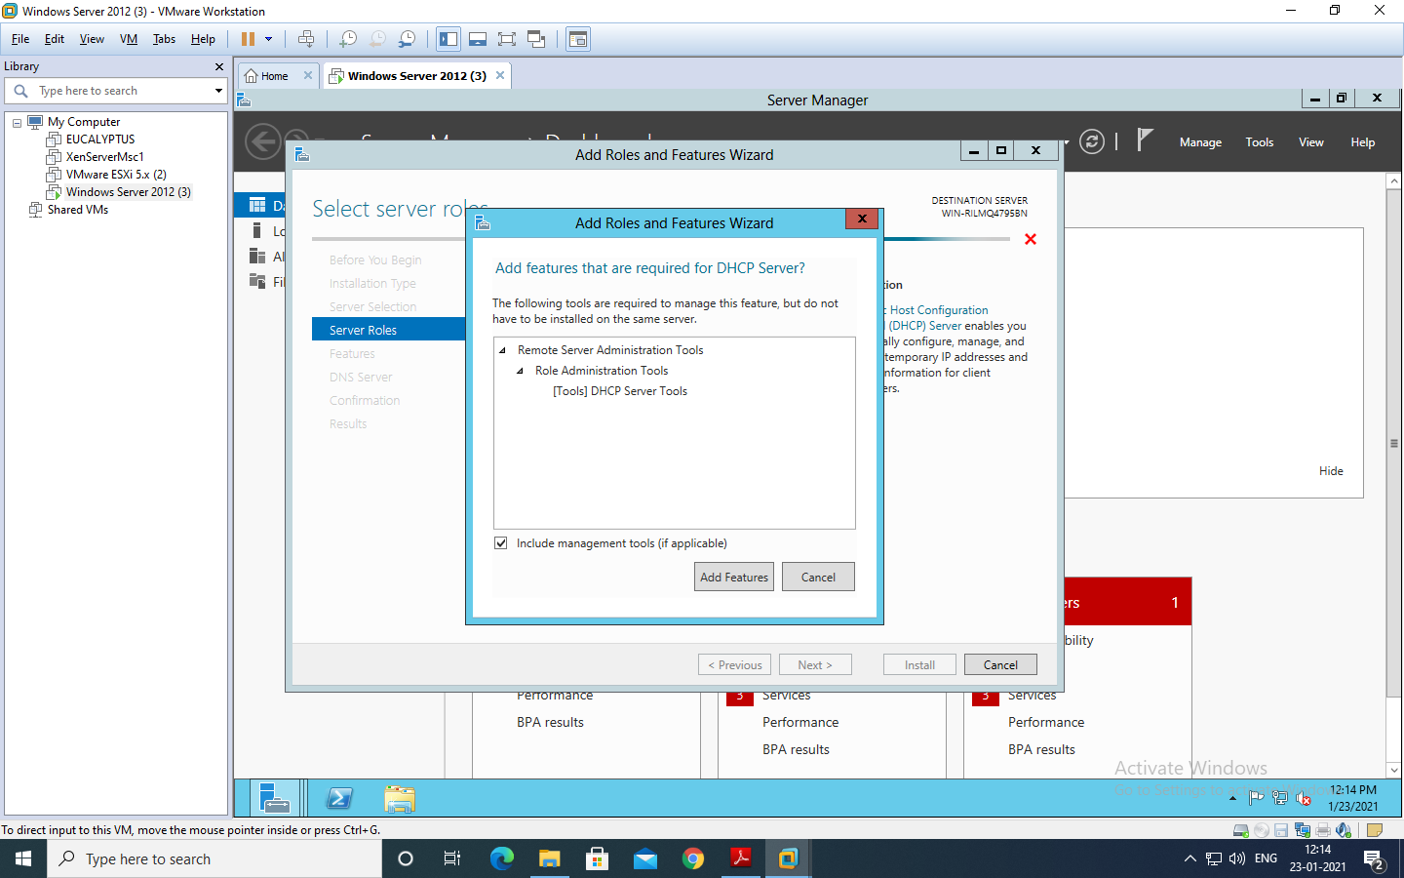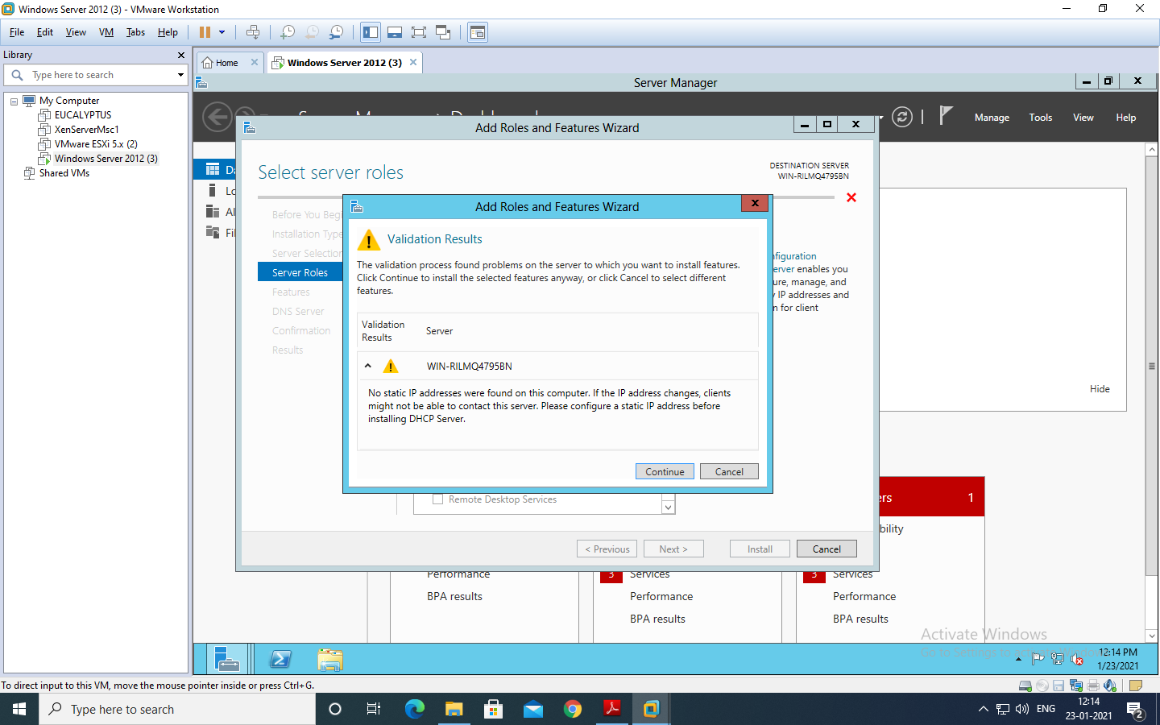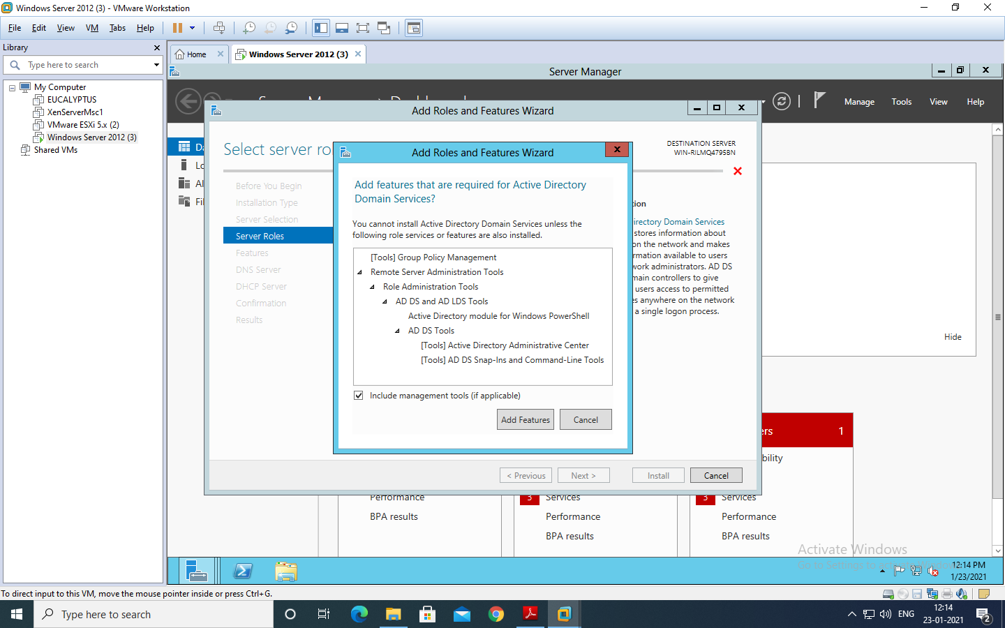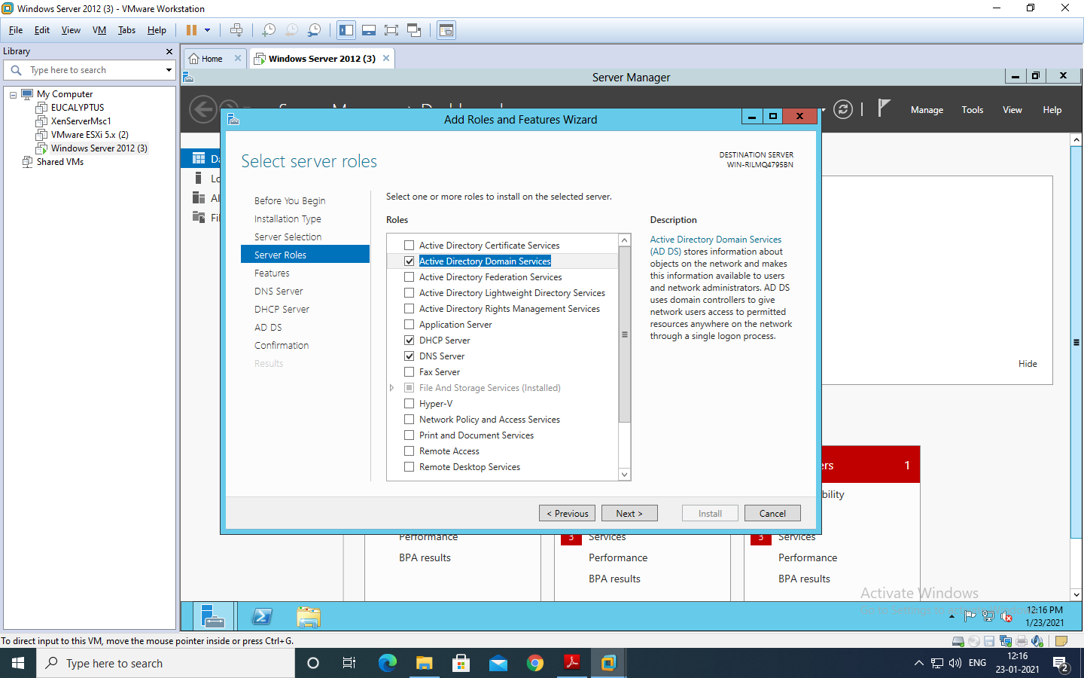 Under “Select Features” select “Failover Clustering” and “.NET Framework 3.5 Features” and click “Next”.

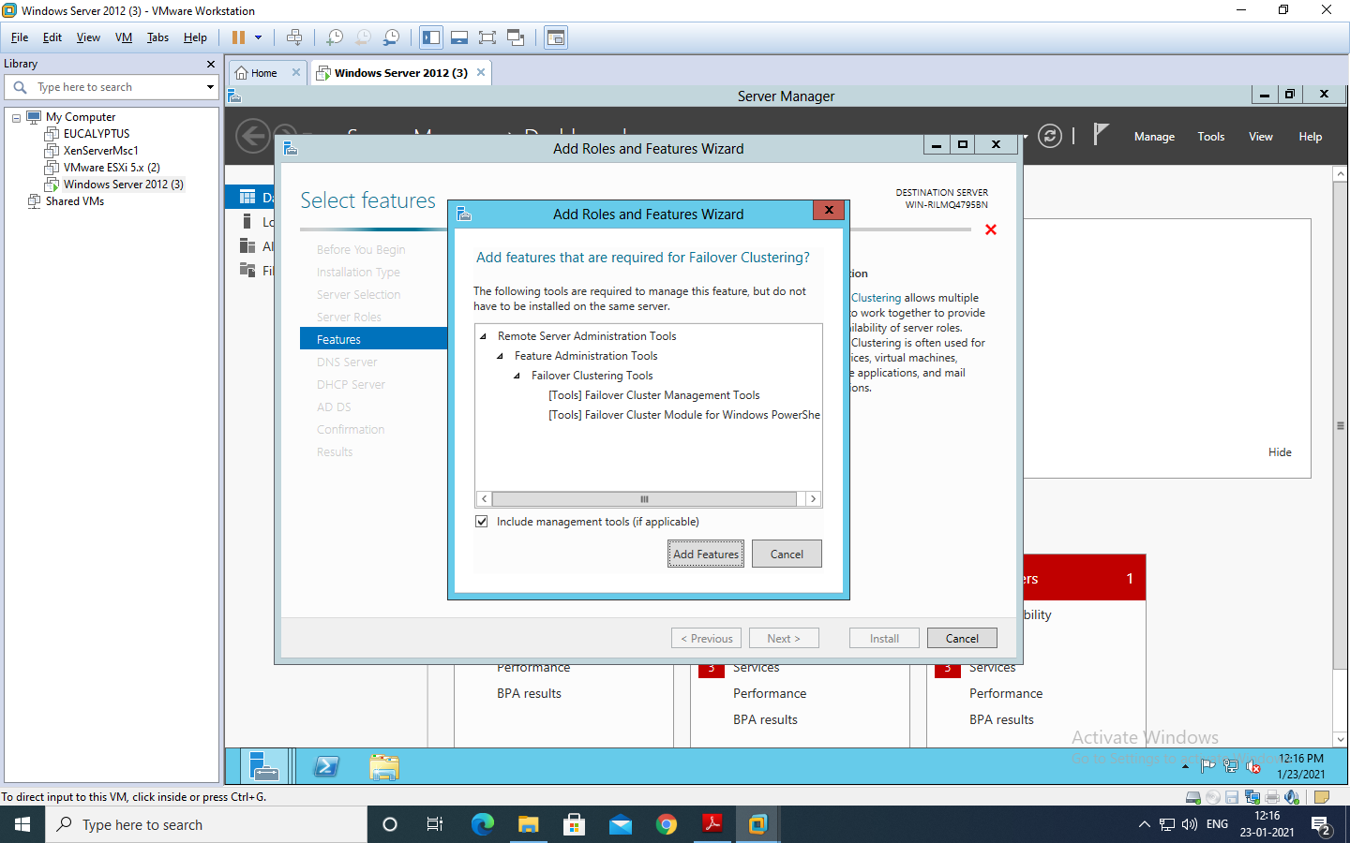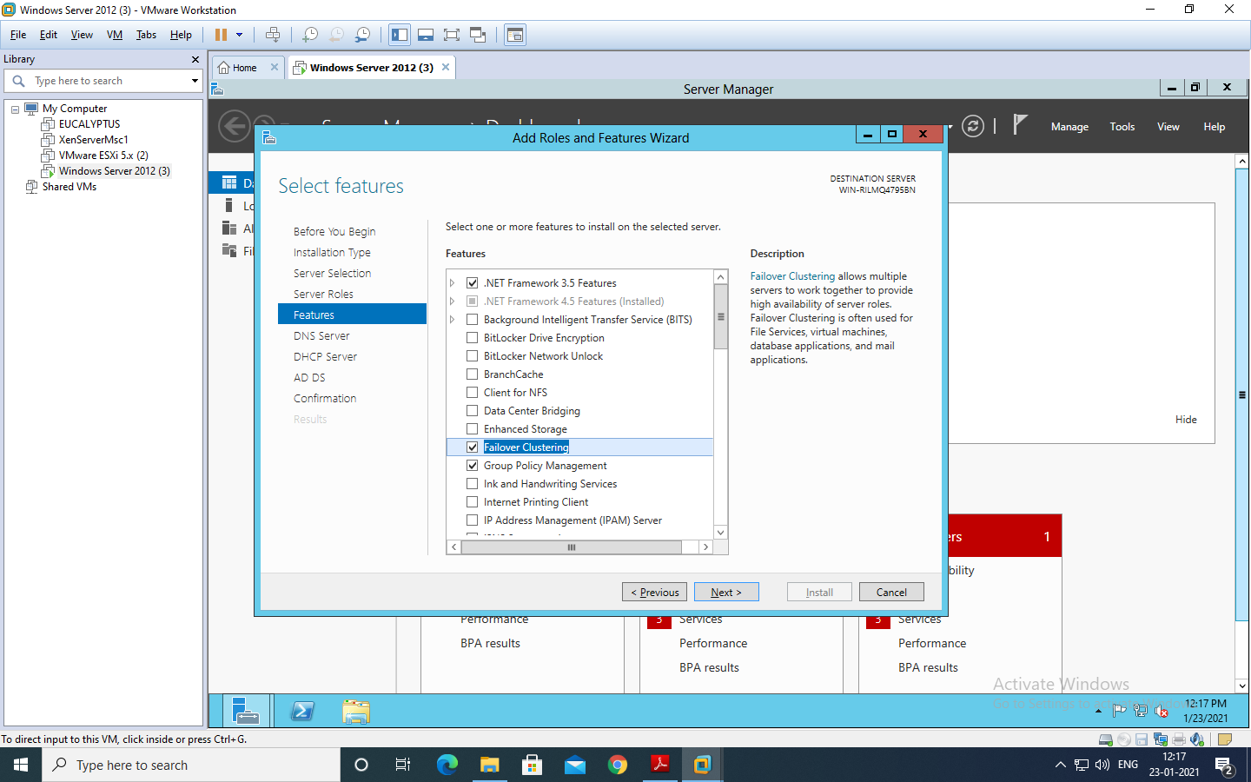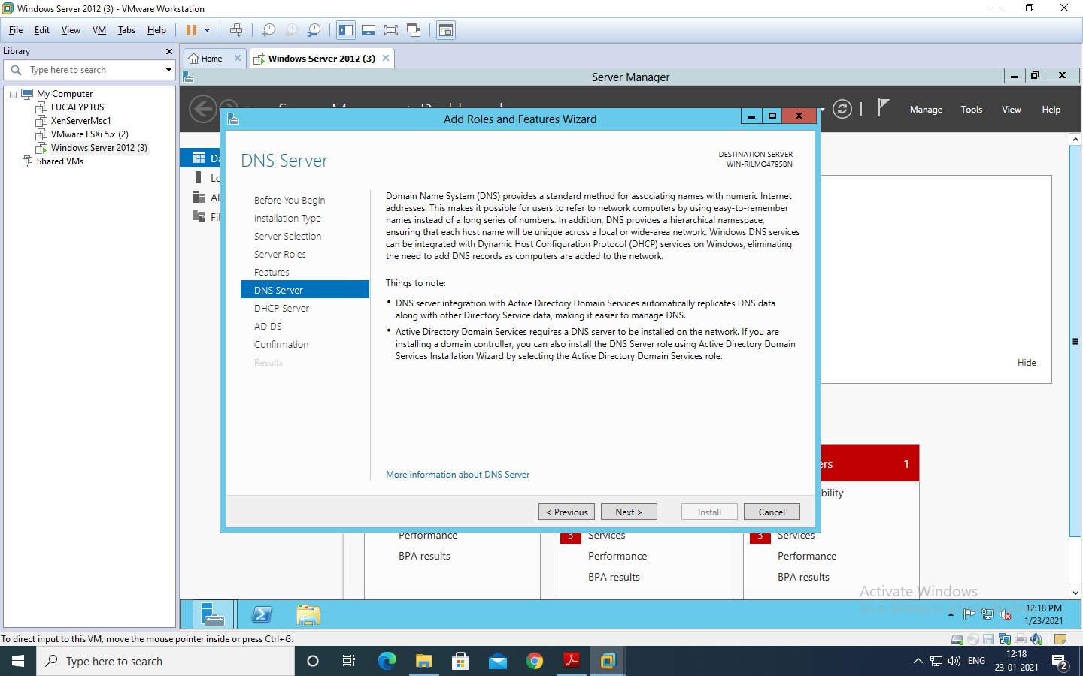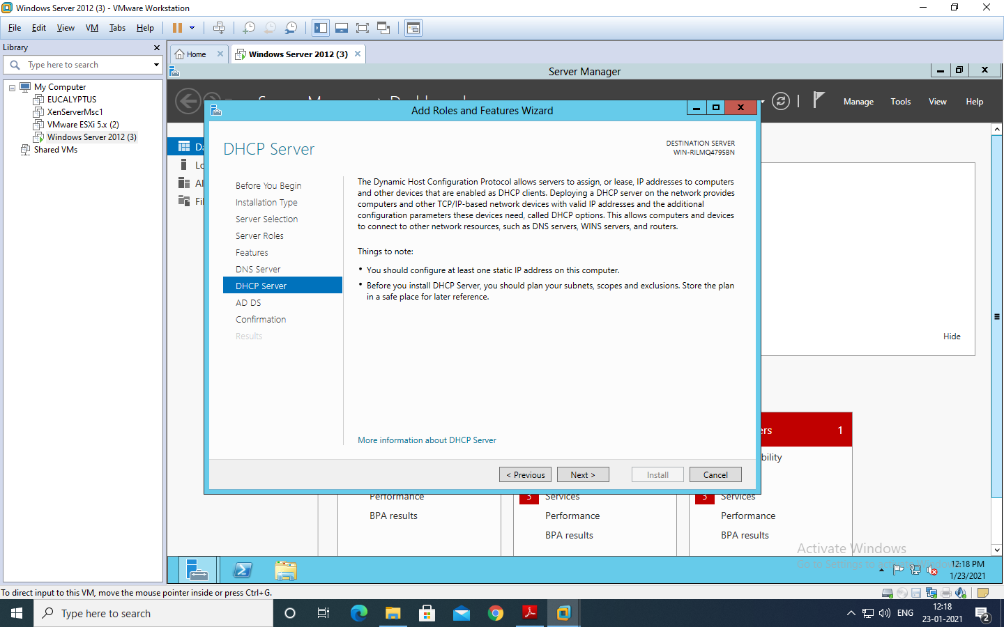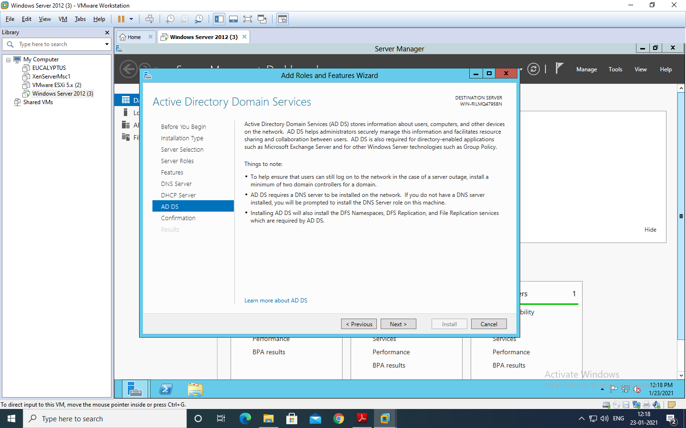

You will see the “Confirm Installation selections” then click on link “specify an alternate path”. As shown in below two screens.

Now, For path specification Go to menu VM->use Iso image file of windows server 2012->Ok Then, Go to File Explorer->Computer -> select the DVD->VIEW FILE-> SOURCES->SXS:

Paste the path Here,

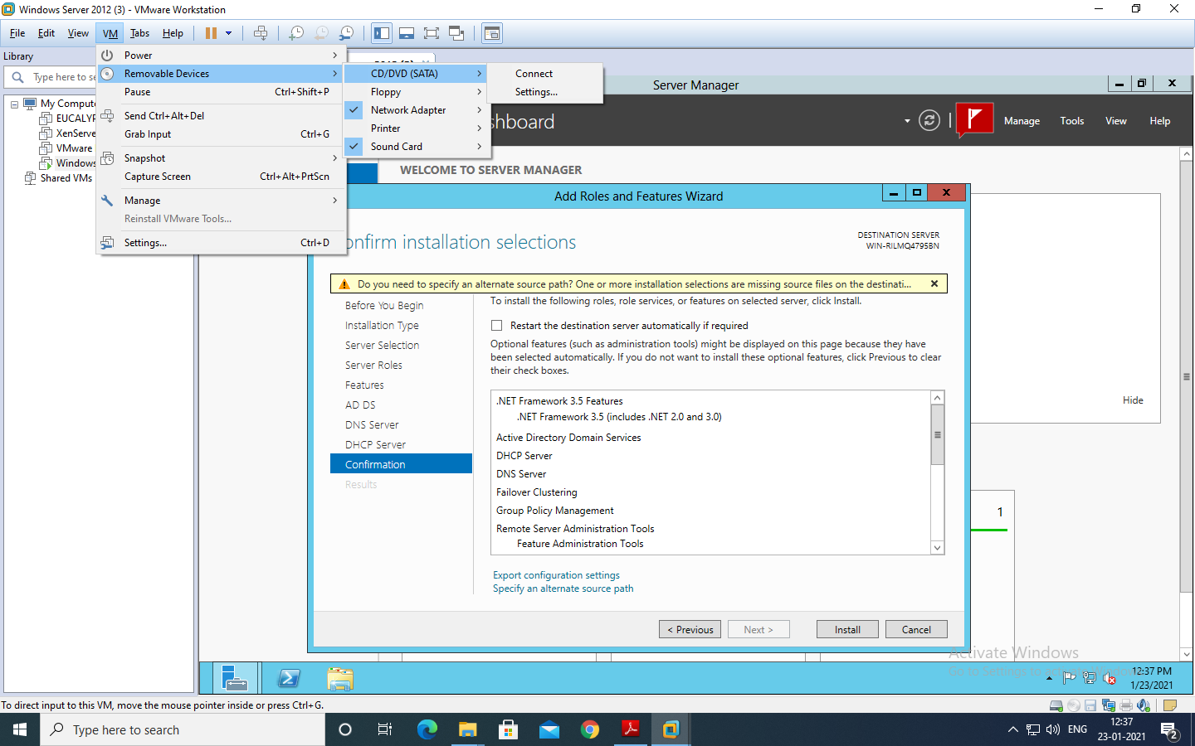

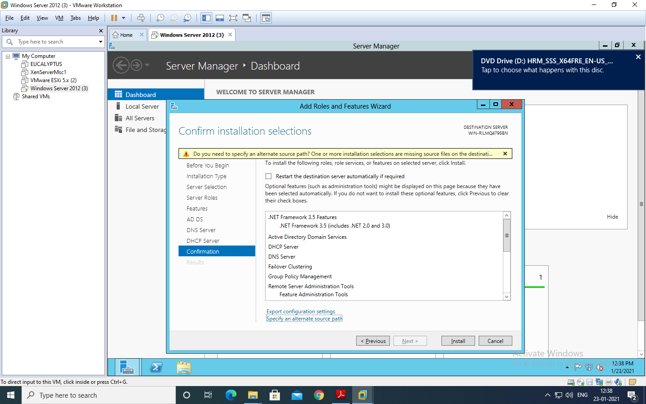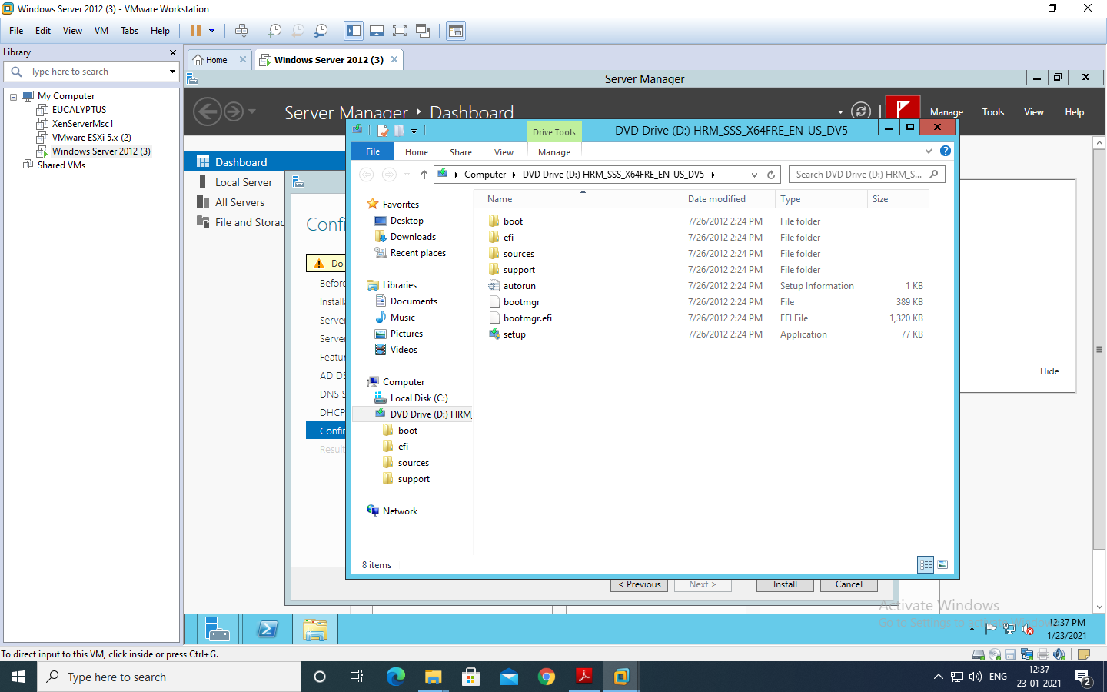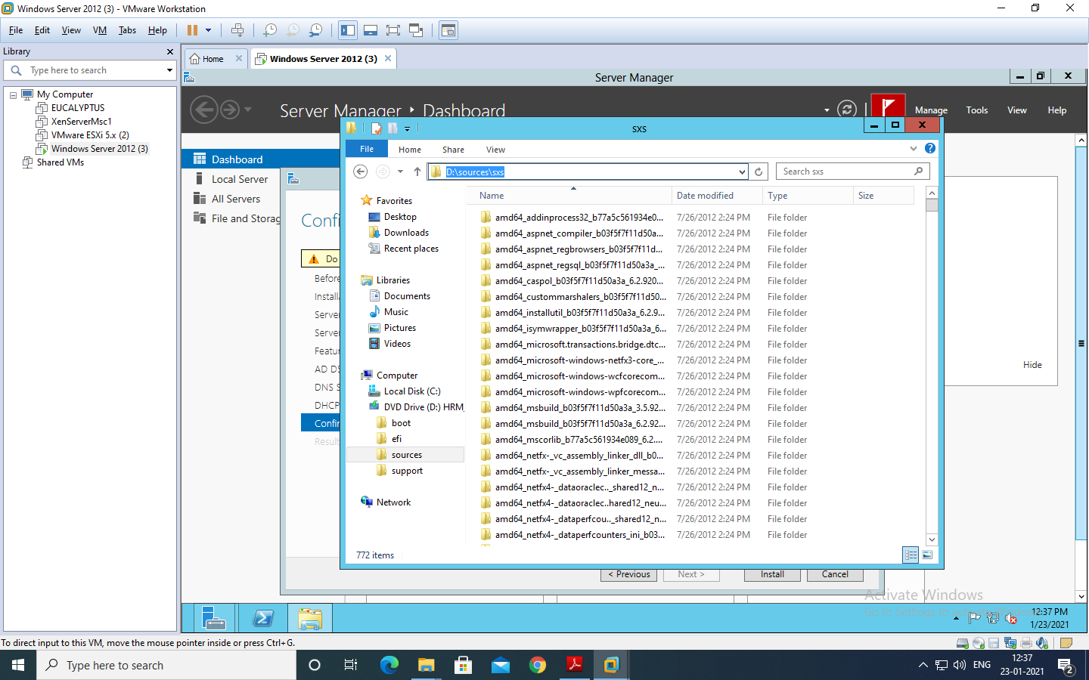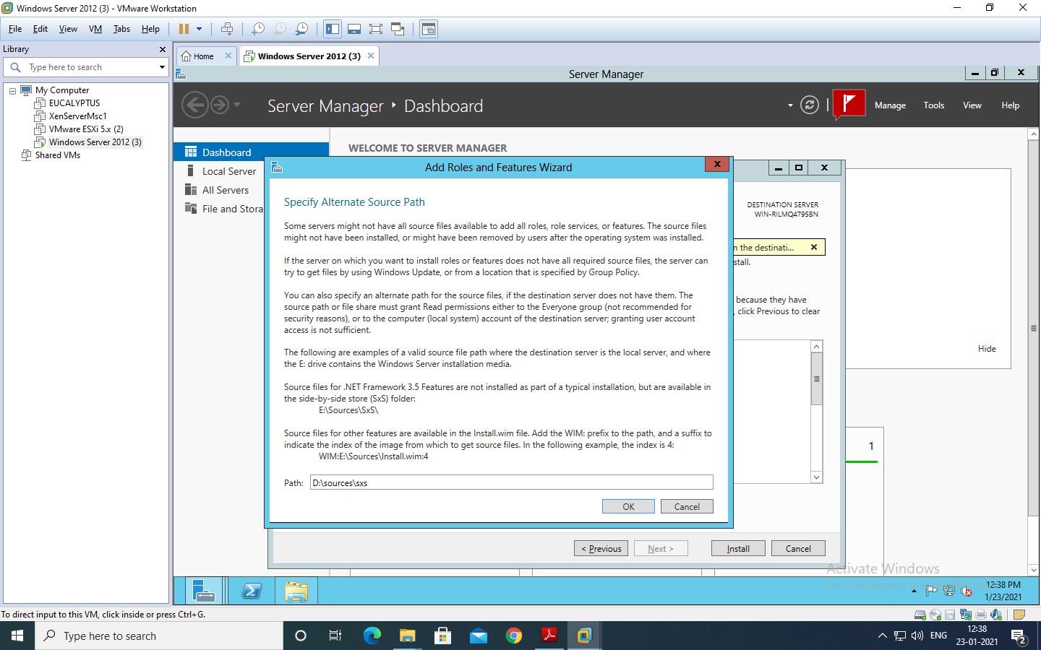

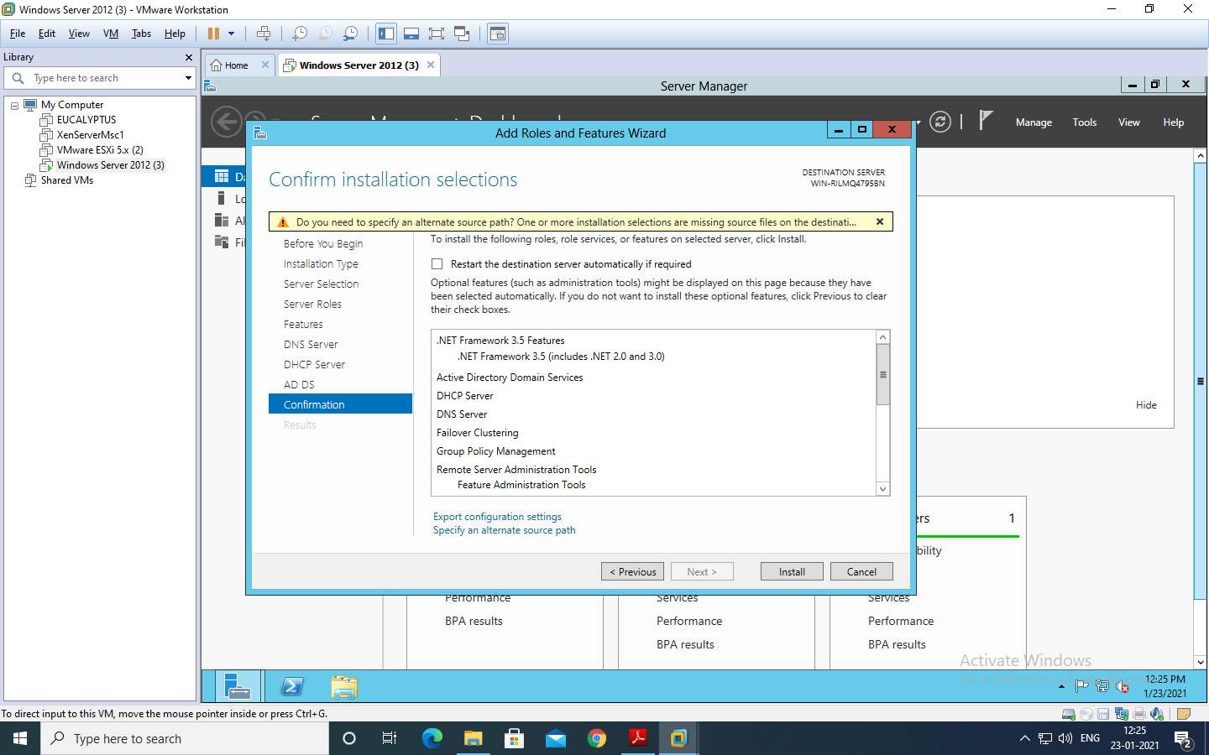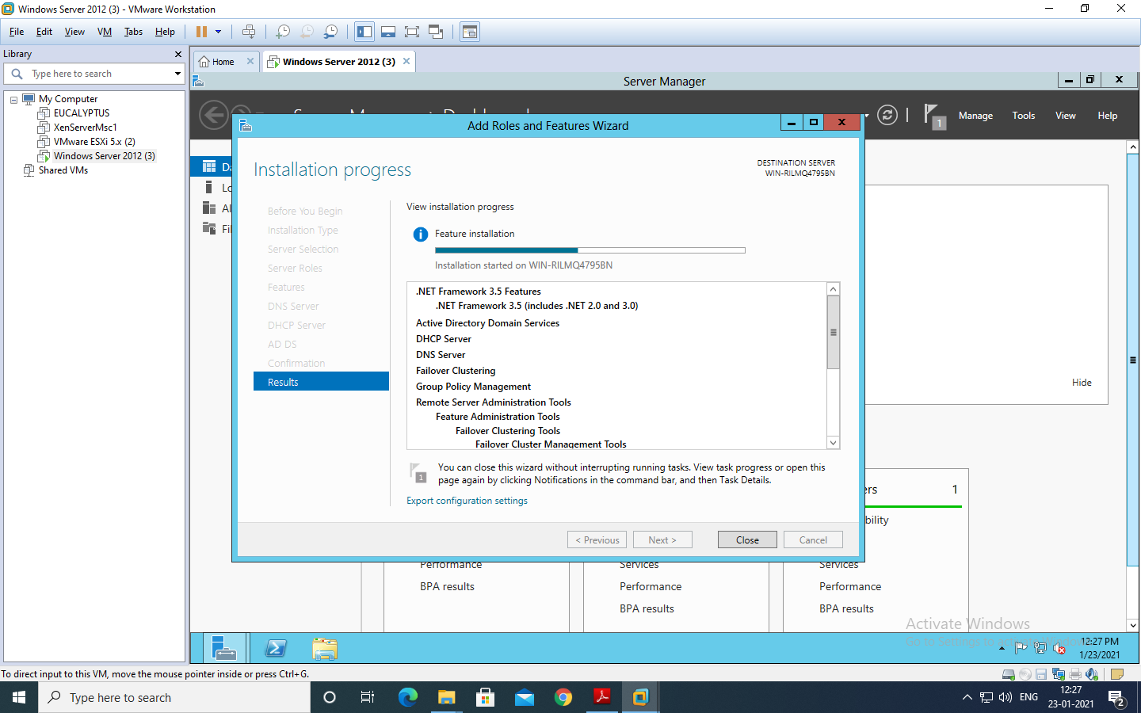 Now, Click on ok and Install button 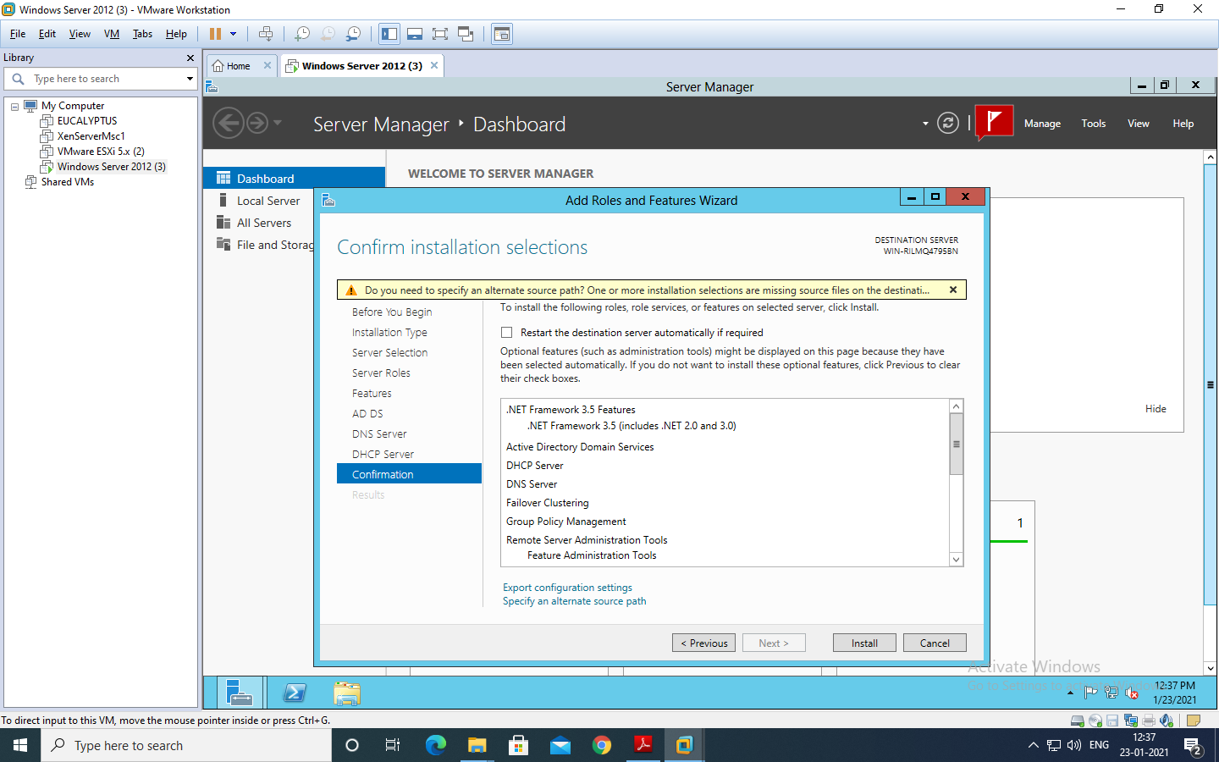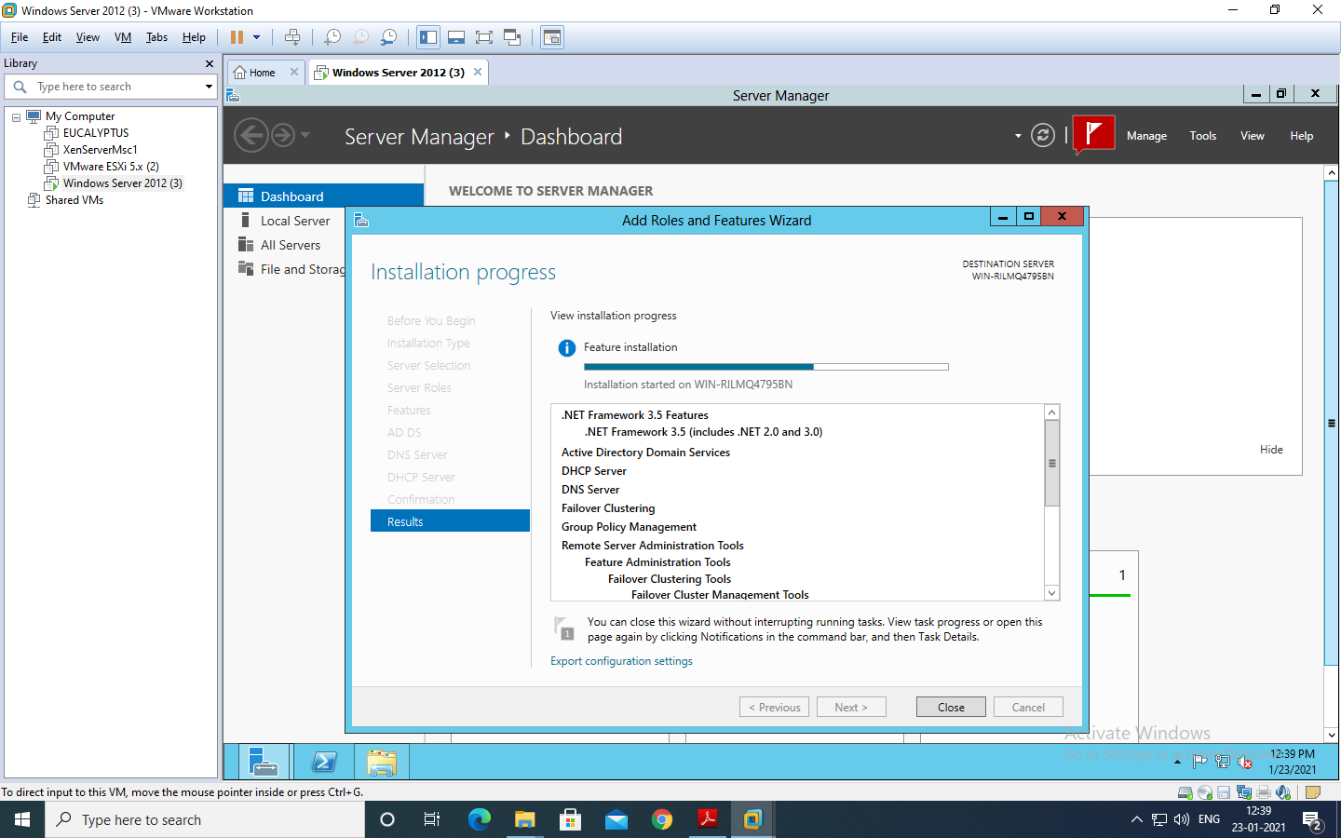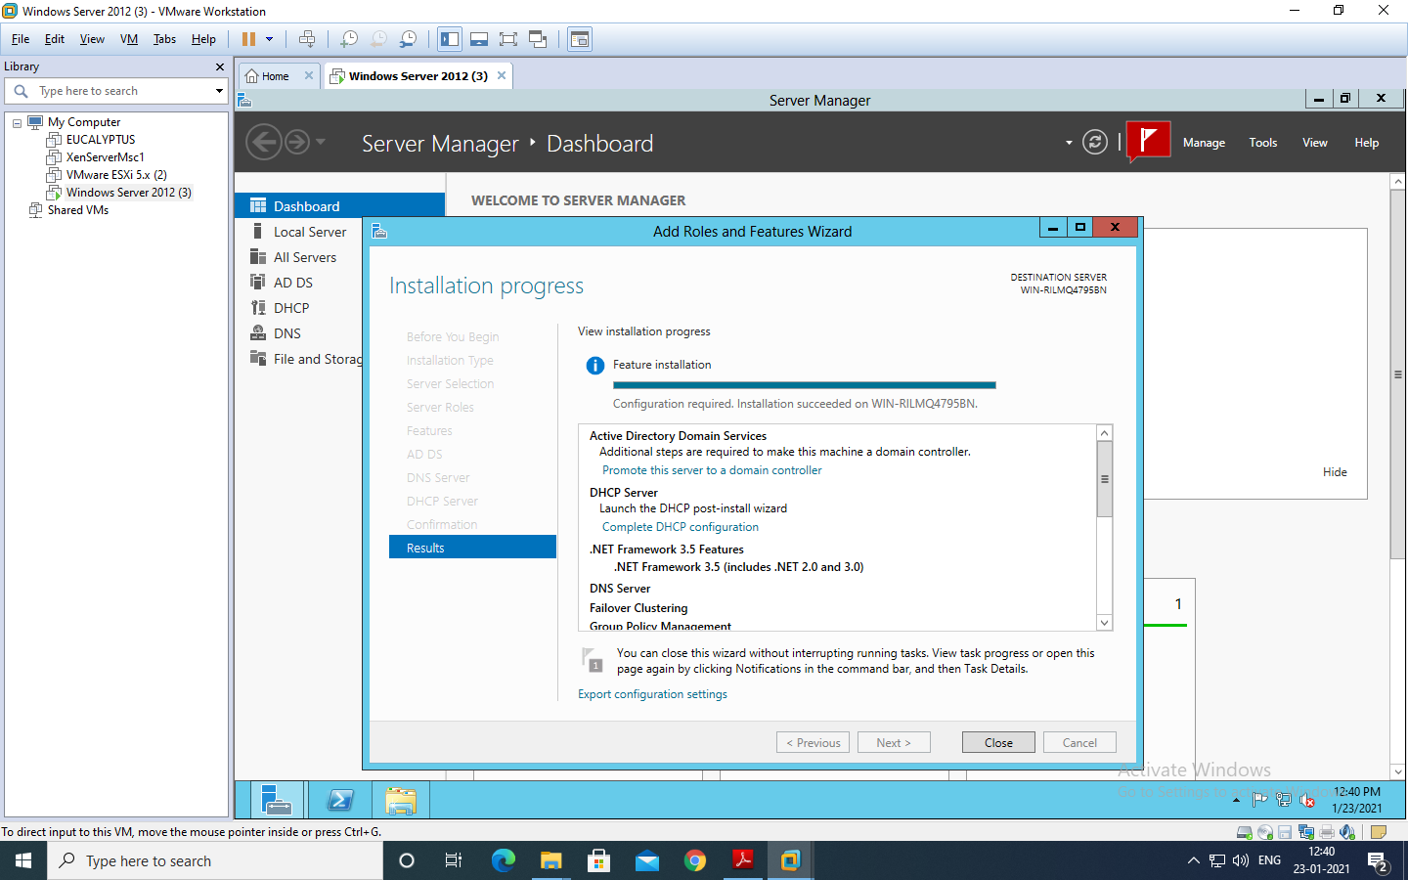

**PROMOTING AS DOMAIN CONTROLLER**

After installation Go to the “ADDS” shown on the left side in the server Manger Dashboard as shown in next screen and click on More, then Click on “Promote this server to a domain controller”.

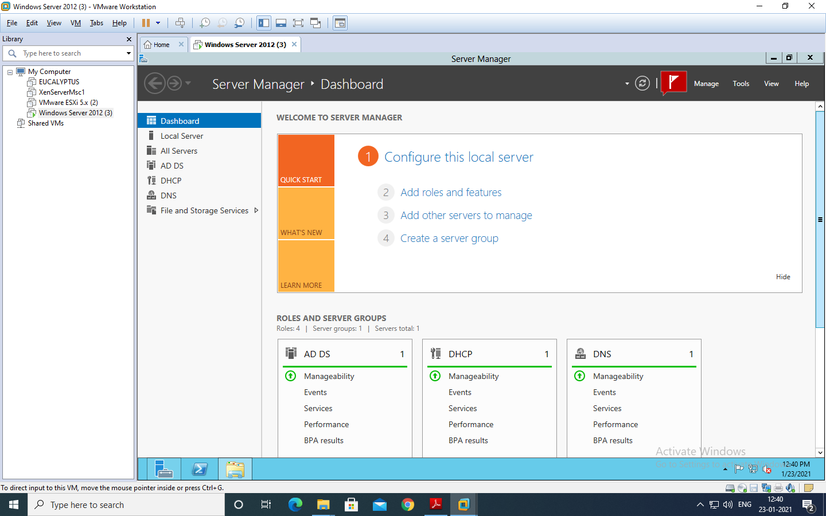

Choose “Add a new forest” option in the “Active Directory Domain services Configuration Wizard” window. Enter the Domain Name “rjcollege.com” as shown in the screen and click “Next”. 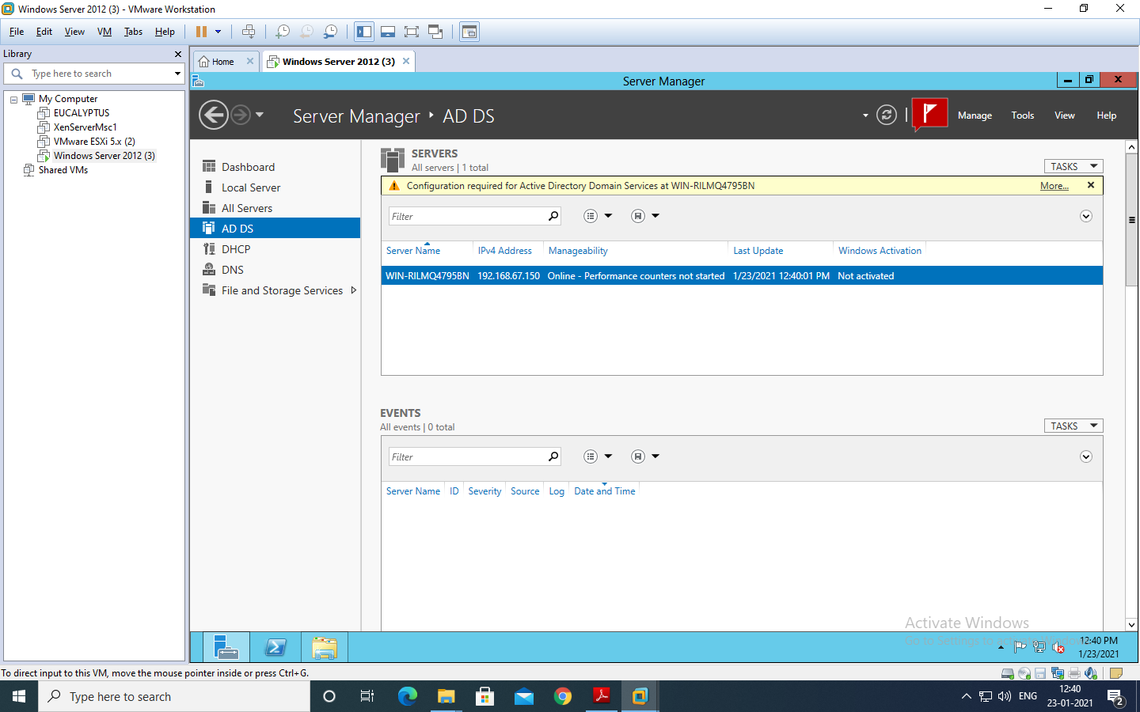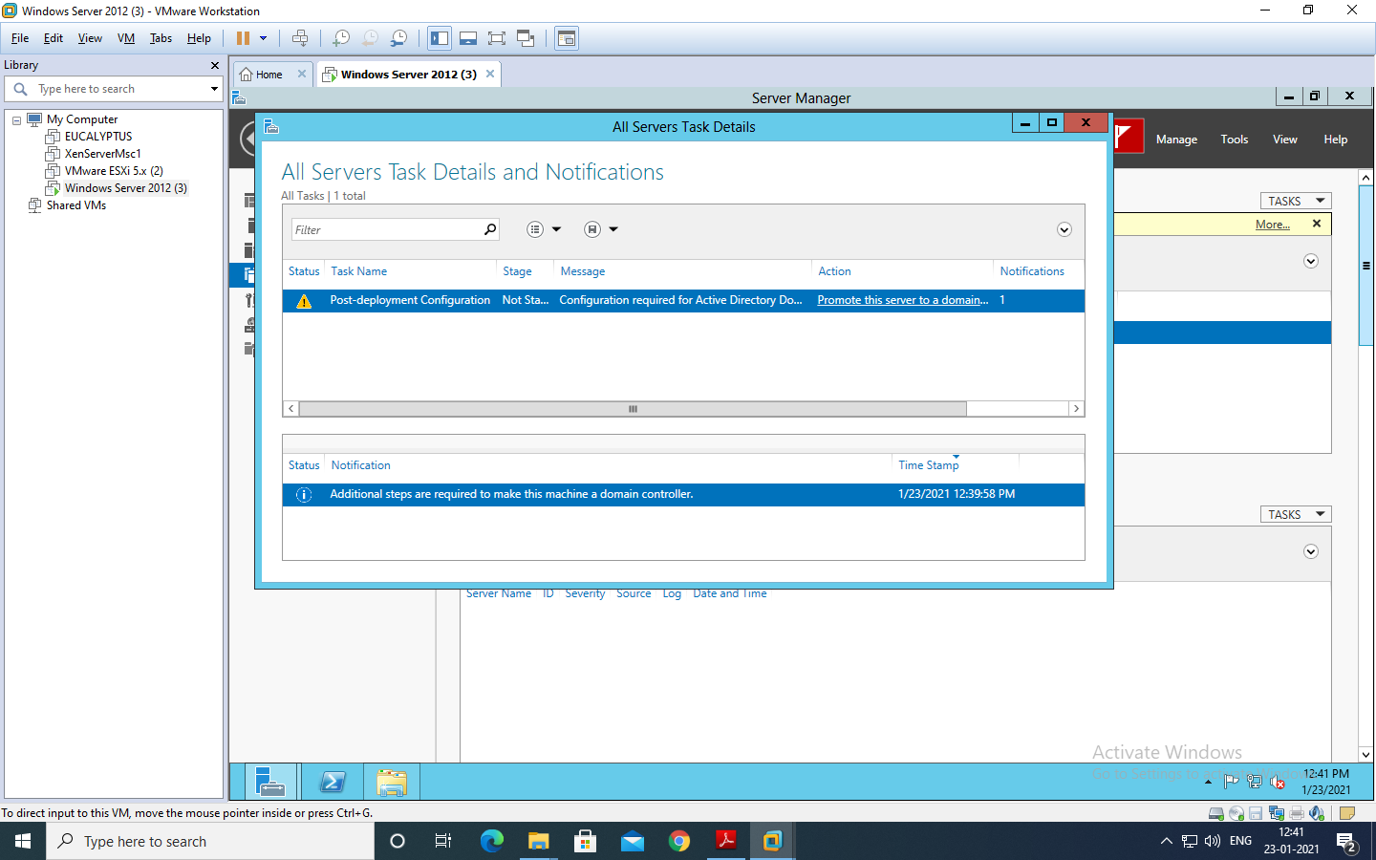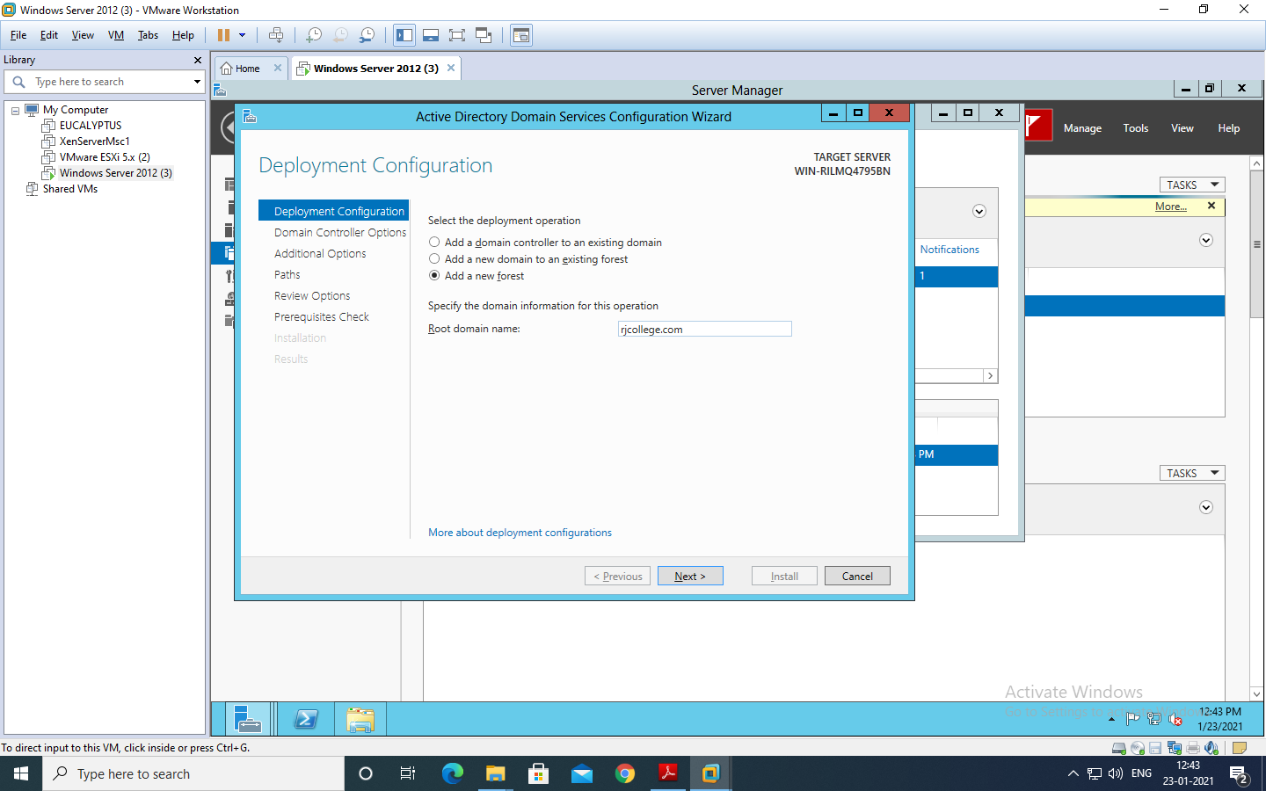Under “Domain Controller Options” enter the alphanumeric password for the “Directory Services Restore Mode (DSRM) PASSWORD”. Preferably use the password given to the Administrators account.

Click “Next” 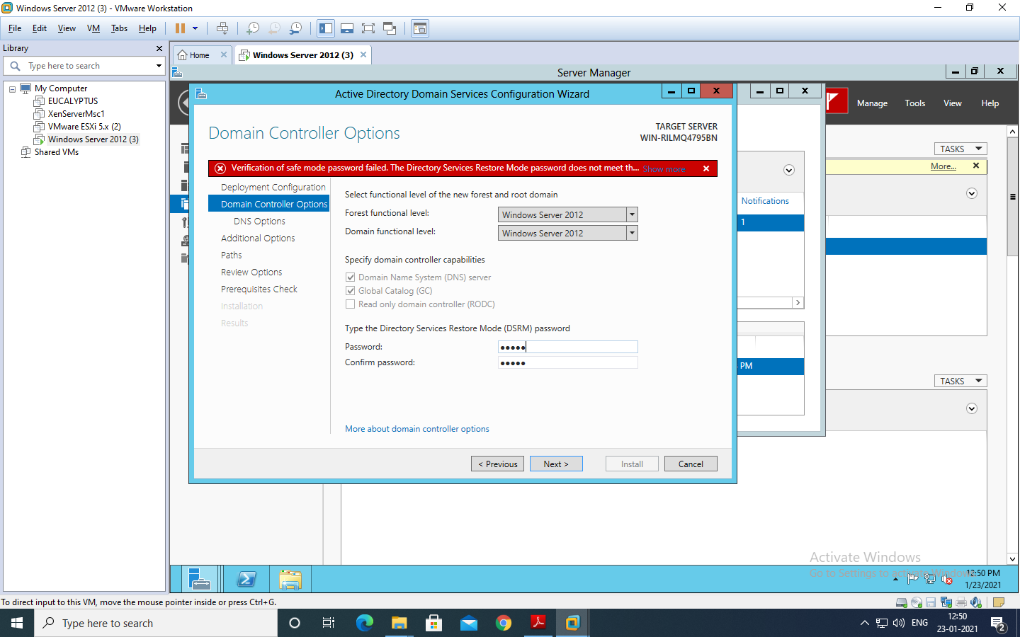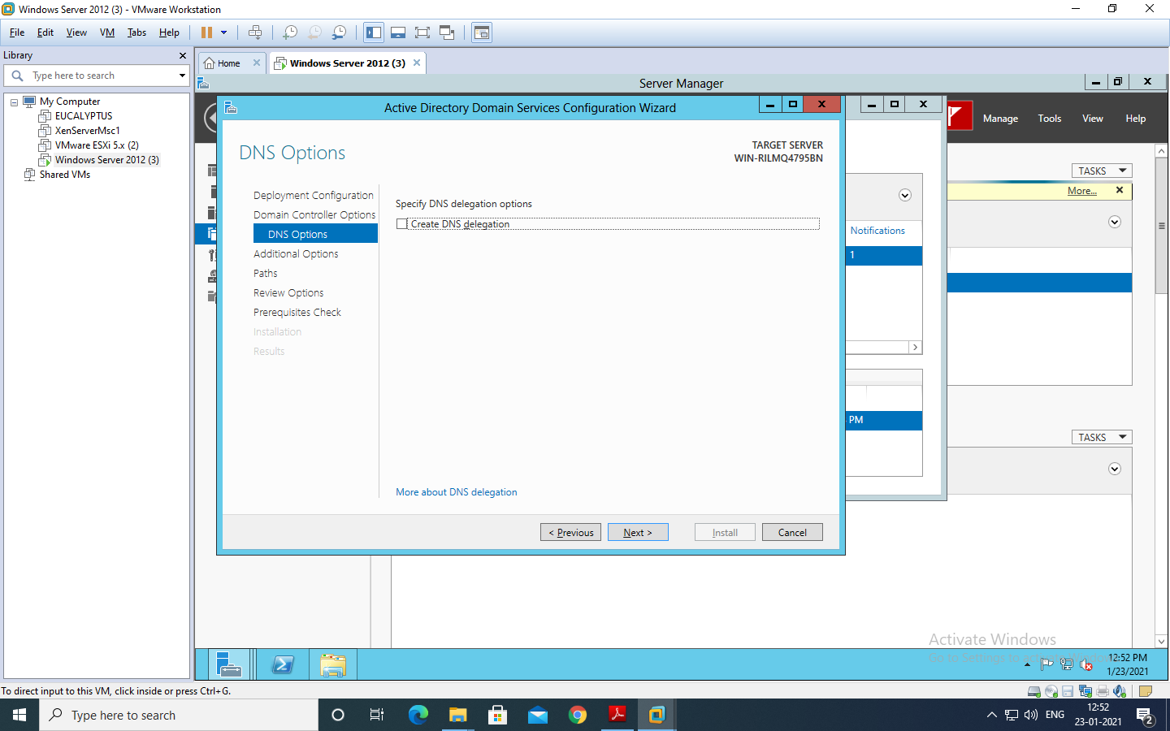The NetBIOS Domain Name appears here automatically. Click “Next”.

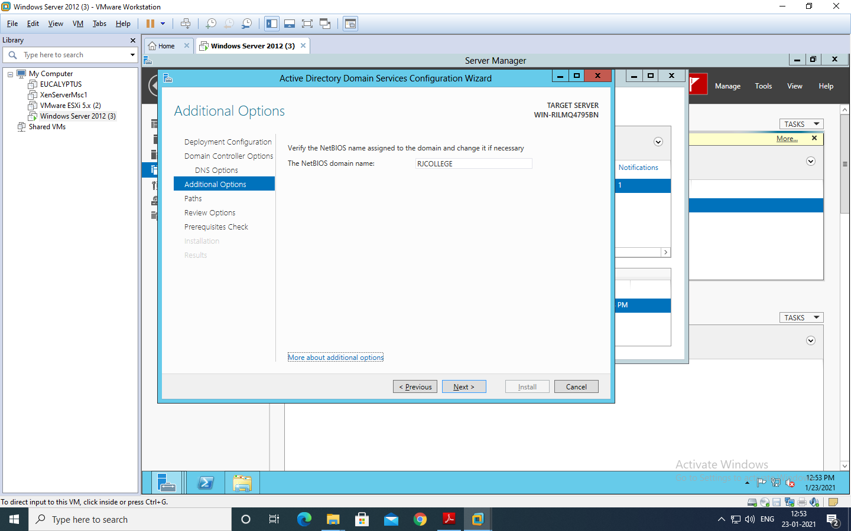

Click “Next”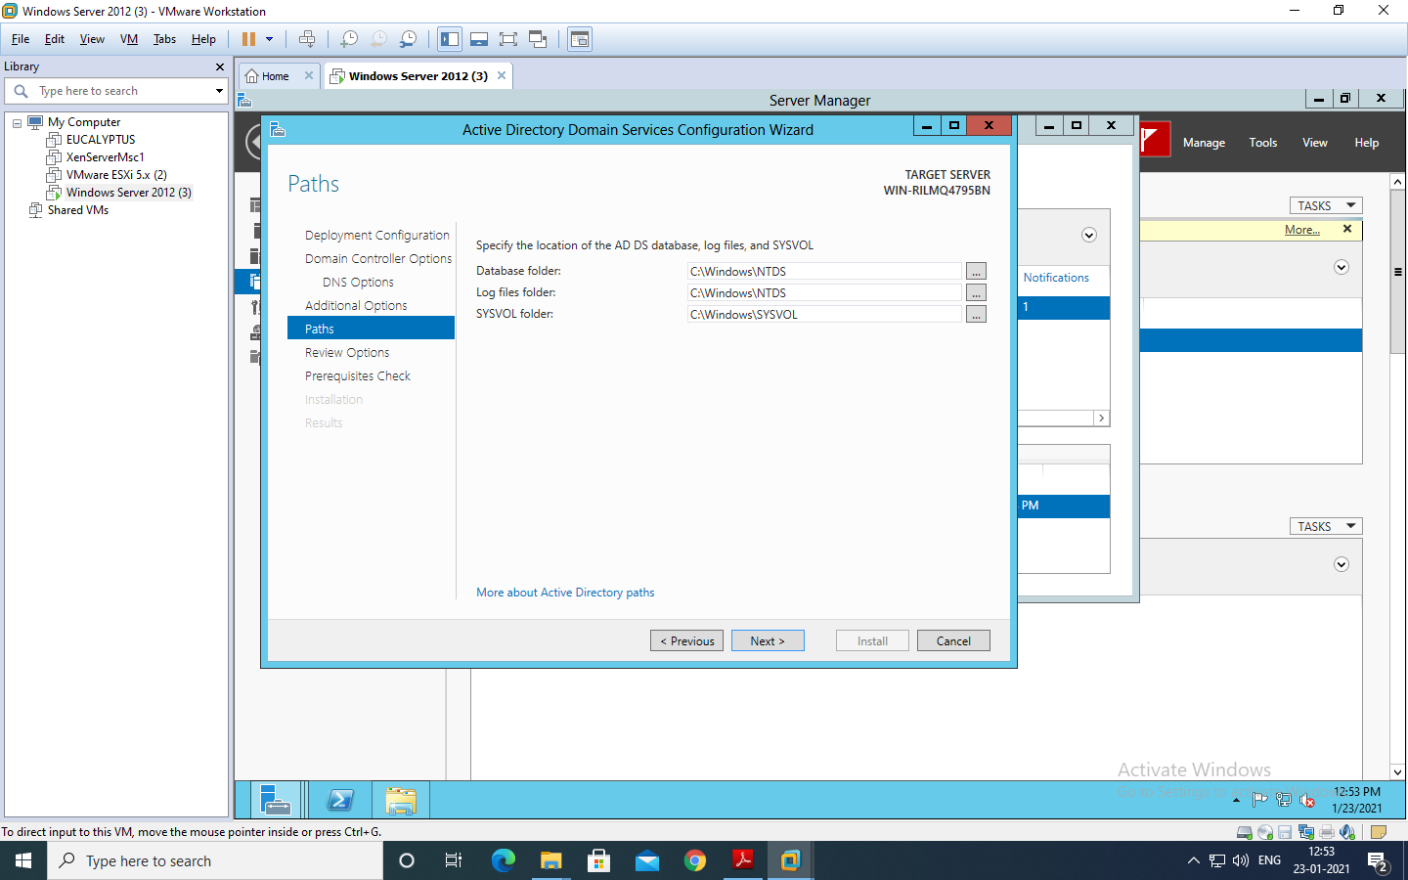 Under “Review Options” it shows us whatever we have selected for the Domain Controller. 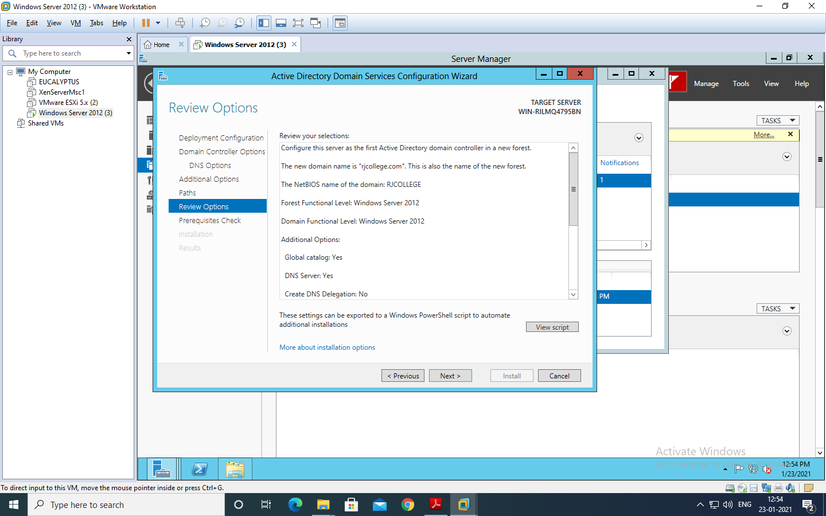 It checks for all the Prerequisites required to create a Domain Controller under “Prerequisites Check”. Click on “Install” button. 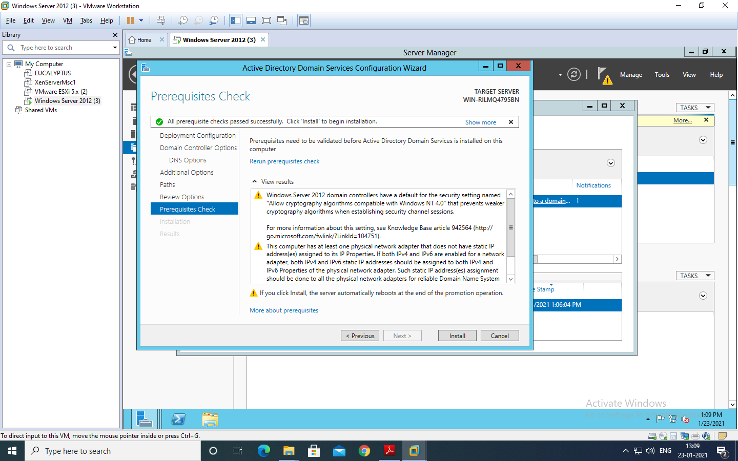

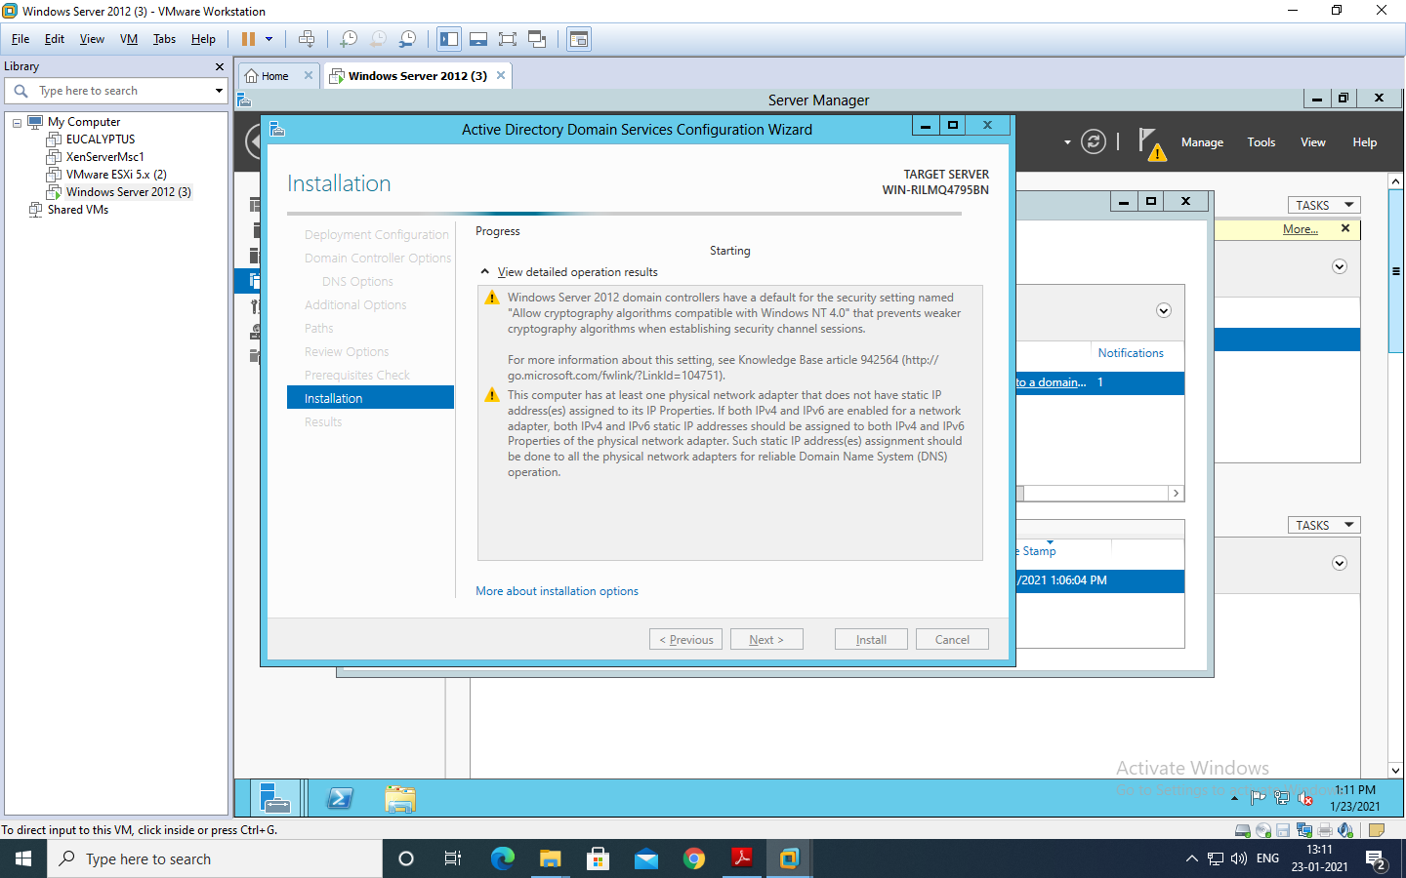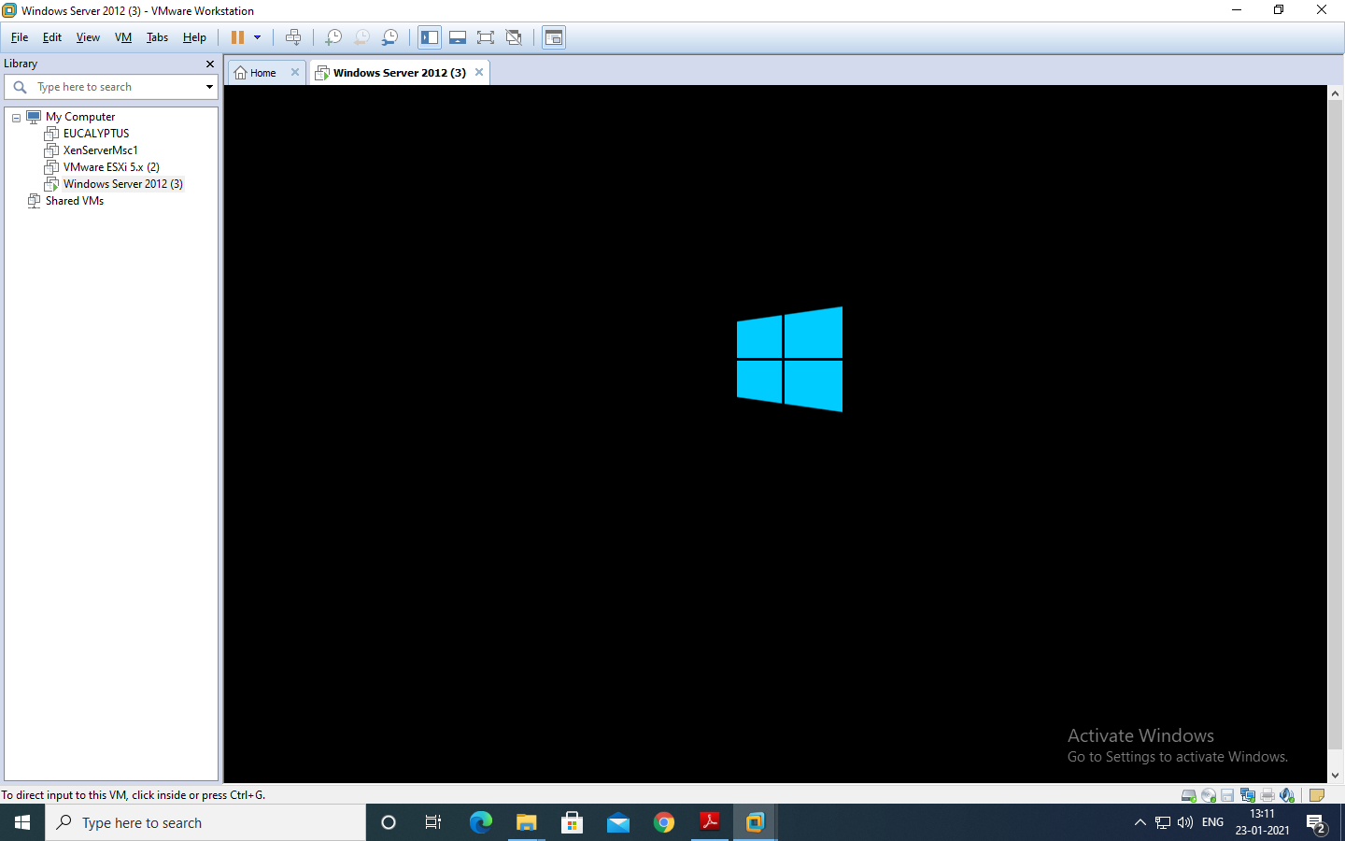 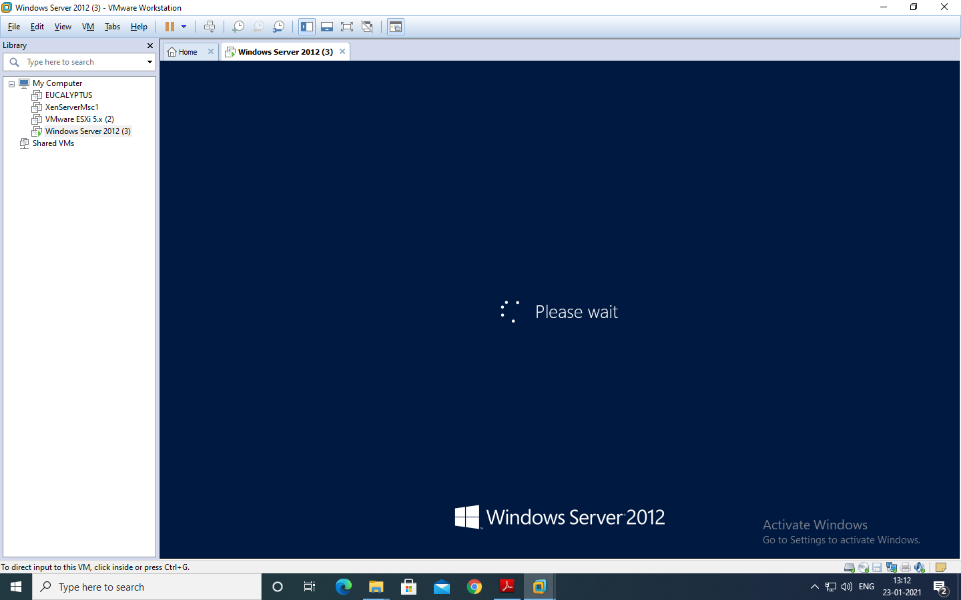

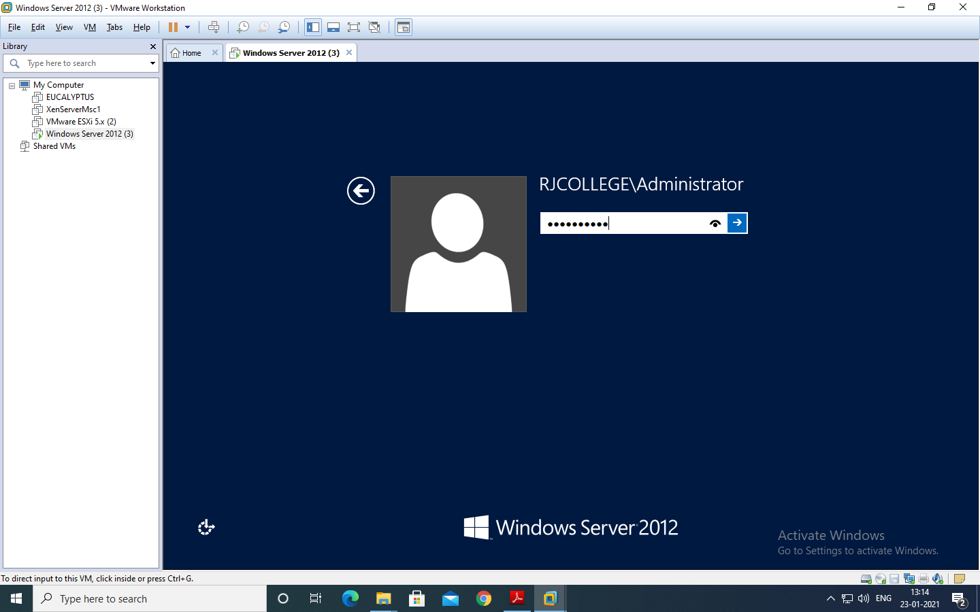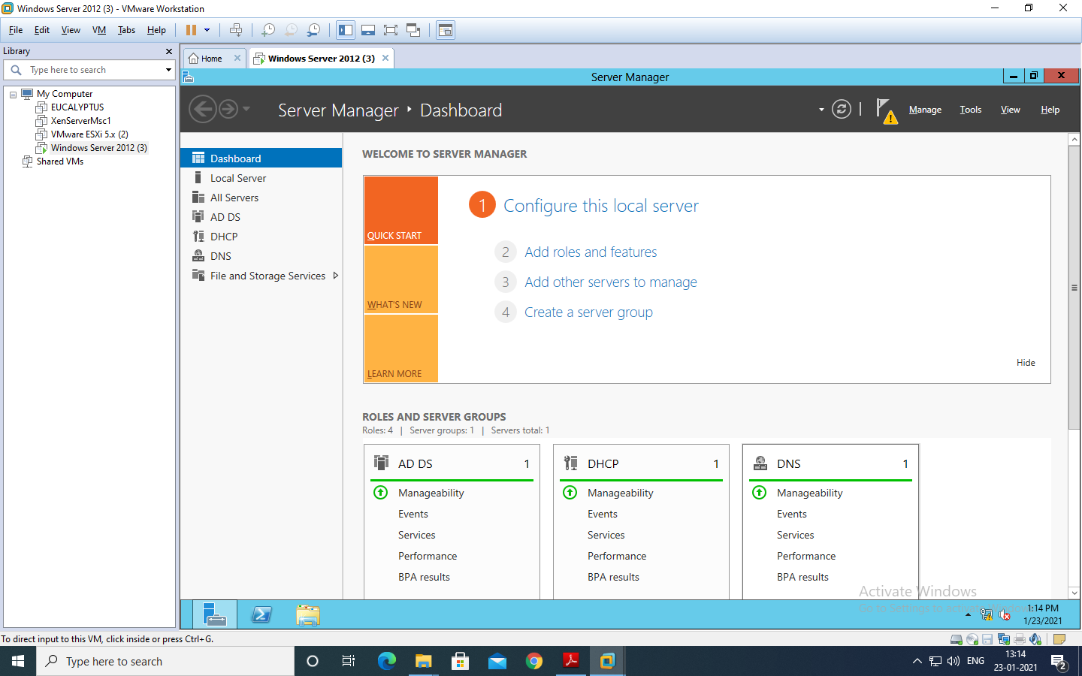

**CREATING FAILOVER CLUSTER**

Click on the “Failover Cluster Manger” under the tools menu to get the following screen.

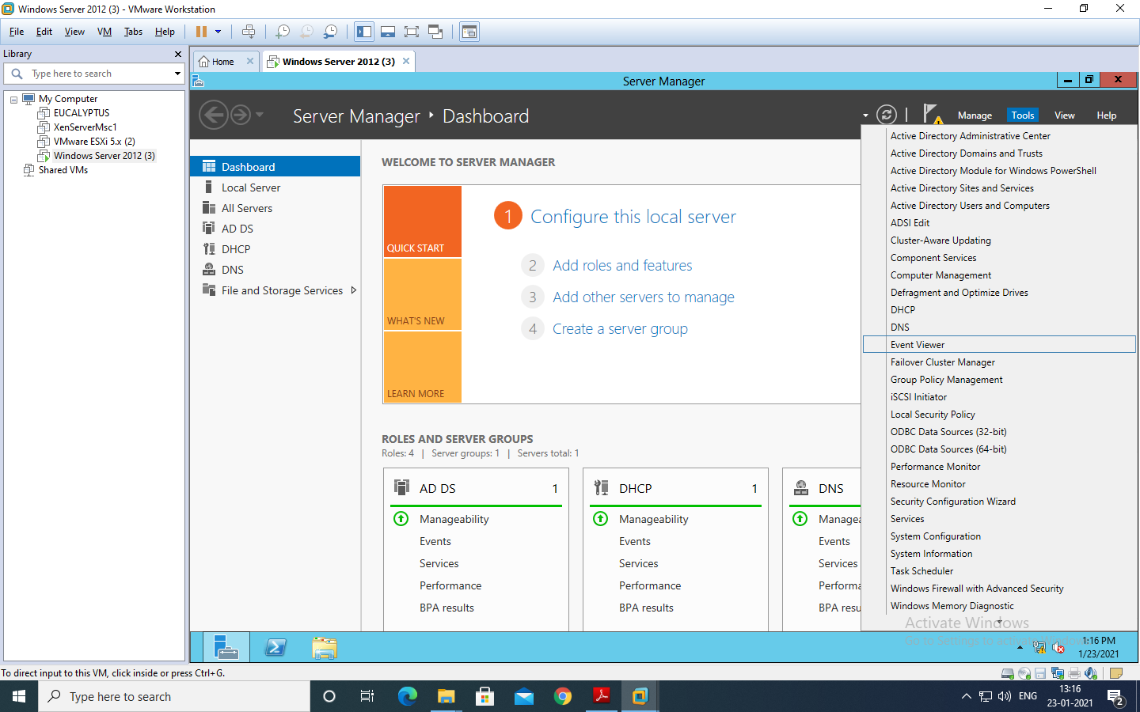

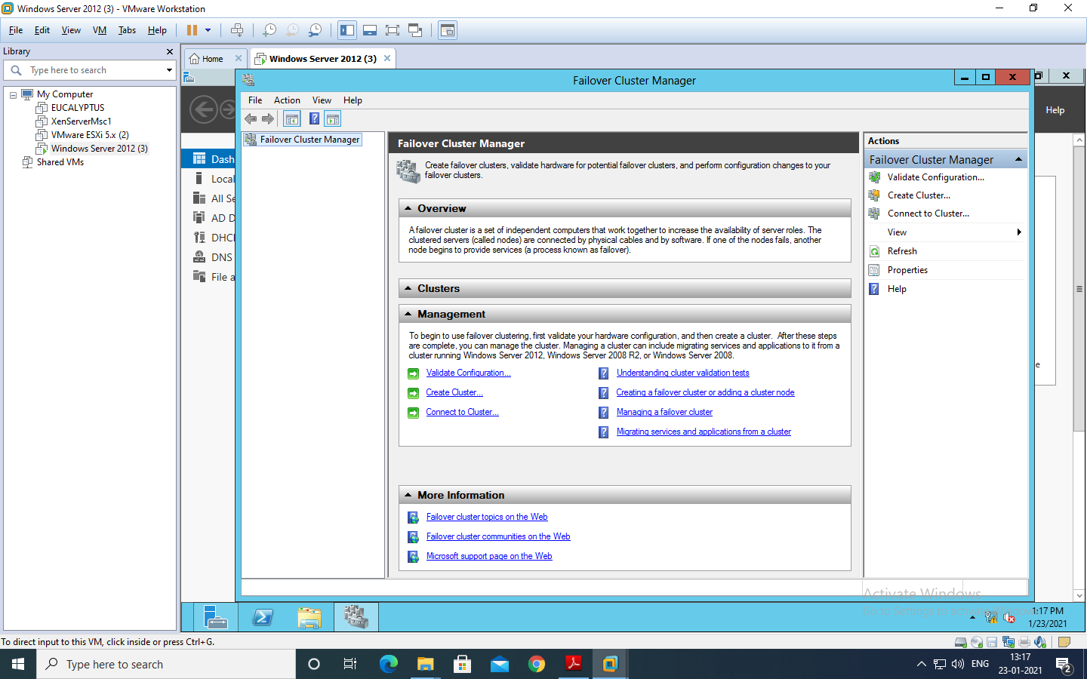

Click on “Validation Configuration” to open the “Validate a Configuration Wizard” by clicking on the “Validate Configuration” under the Management section at the bottom or right side of the screen. The nodes to be added must be validated prior to add in the

cluster. Click “Next”.

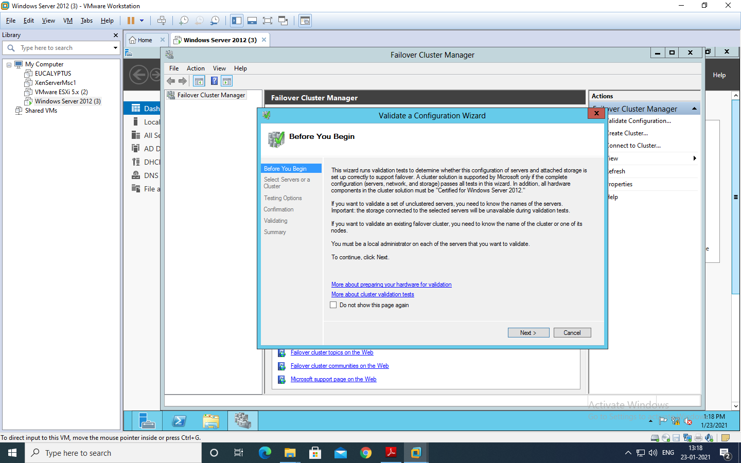

In this screen, click on Browse button and then Advanced for finding the domain node. As shown in below screens.

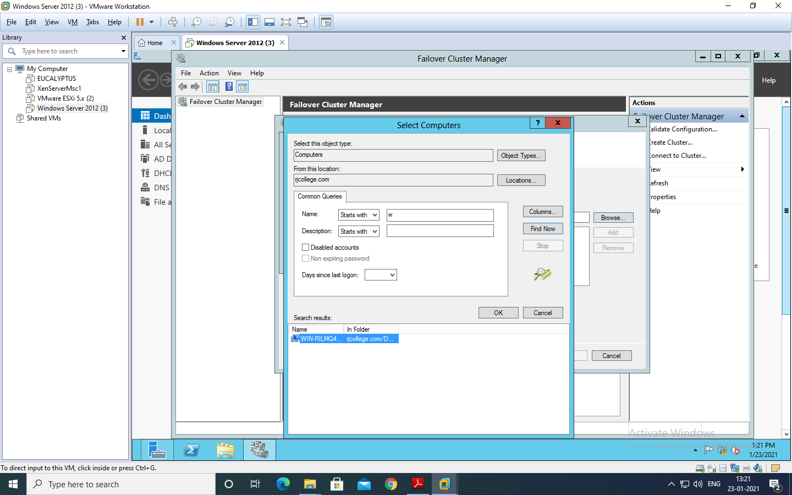

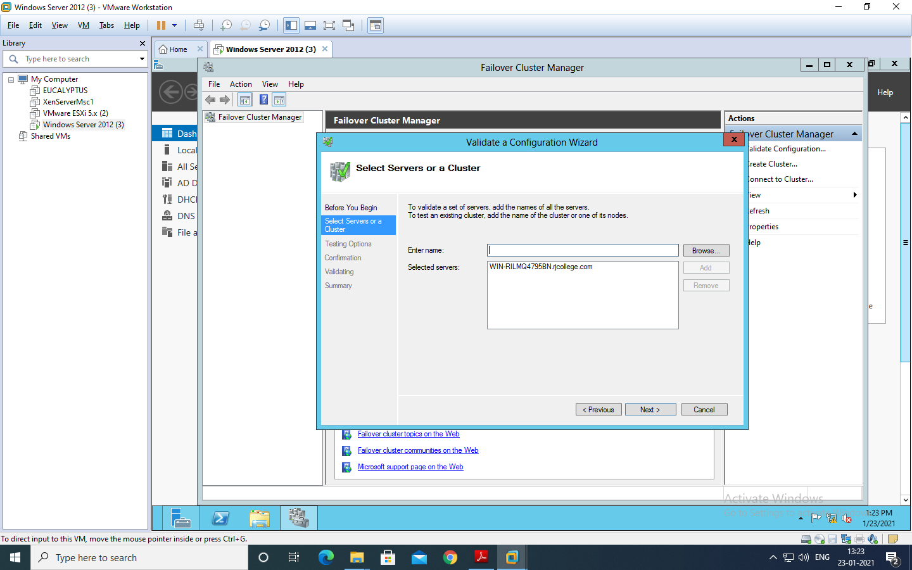

Click on **run all test**

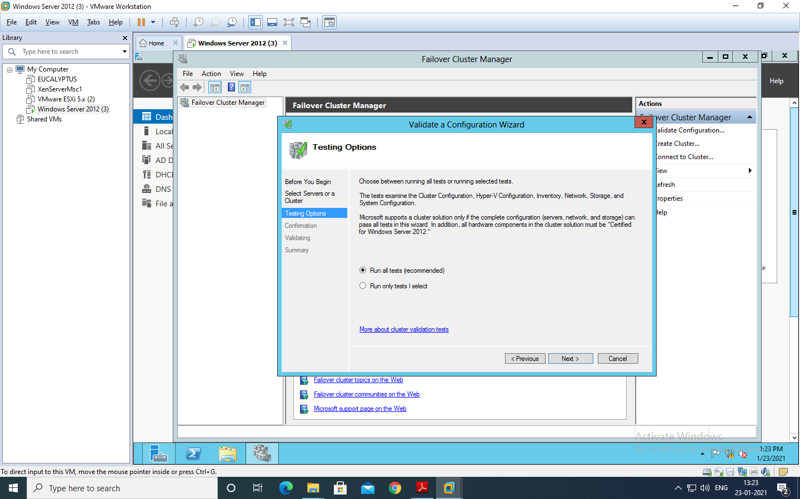

Choose “Run all the tests(recommended)” and click “Next” and then it will ask for the confirmation click “Next”. It will start all test validation.

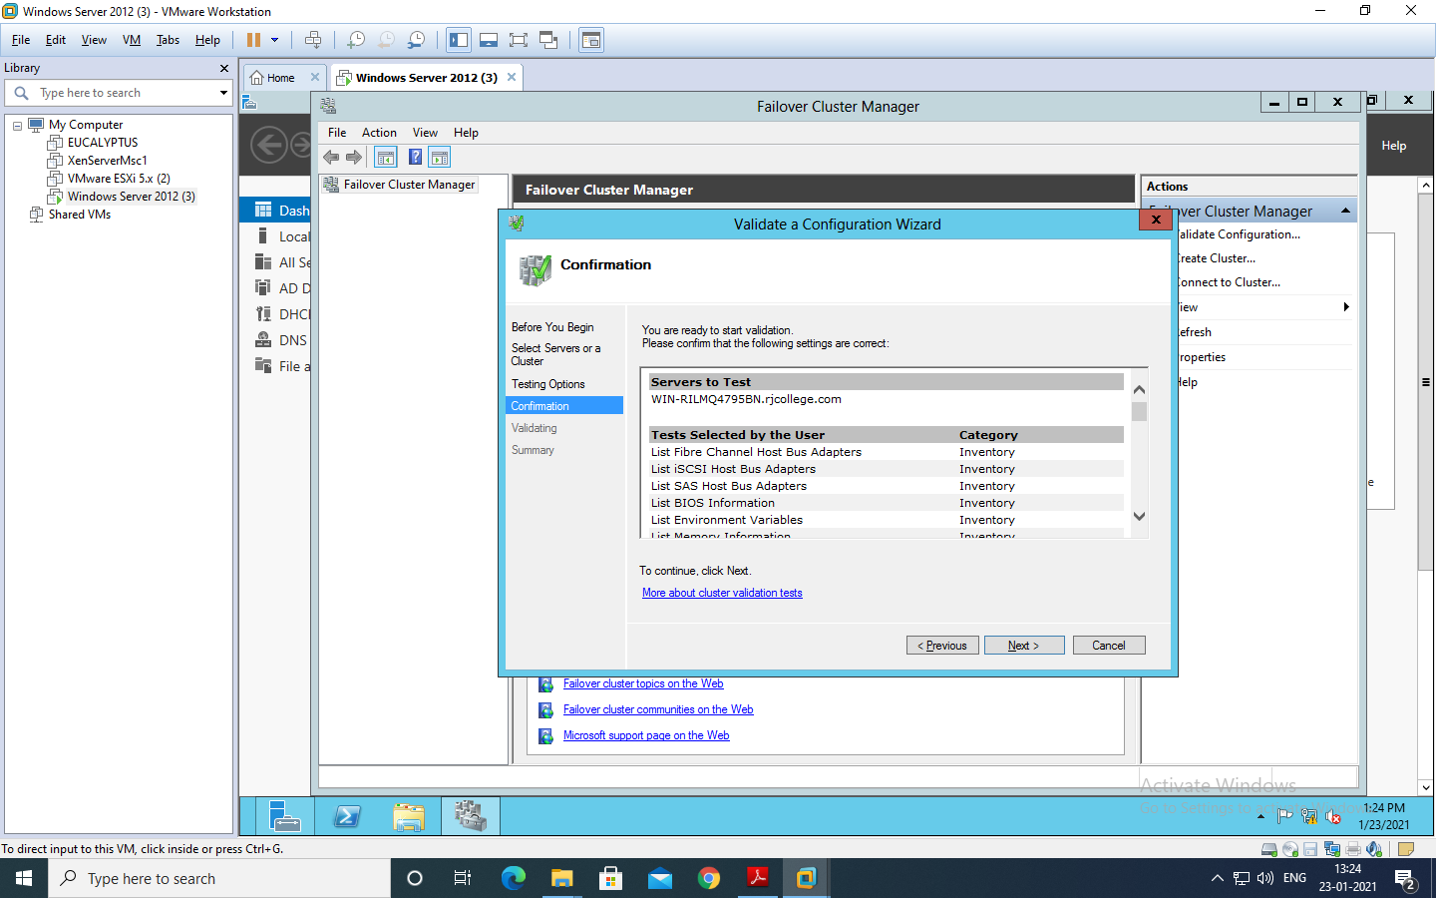

After completion it will display the summary report as shown below. If there are any errors can be seen here and you will not be allowed to create the cluster. As shown in the screen we can see that the nodes are validated. Click on finish.

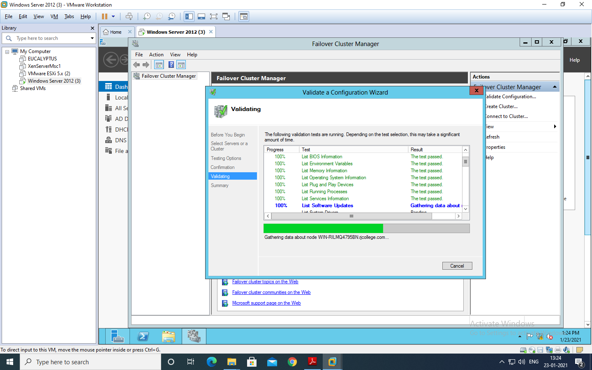

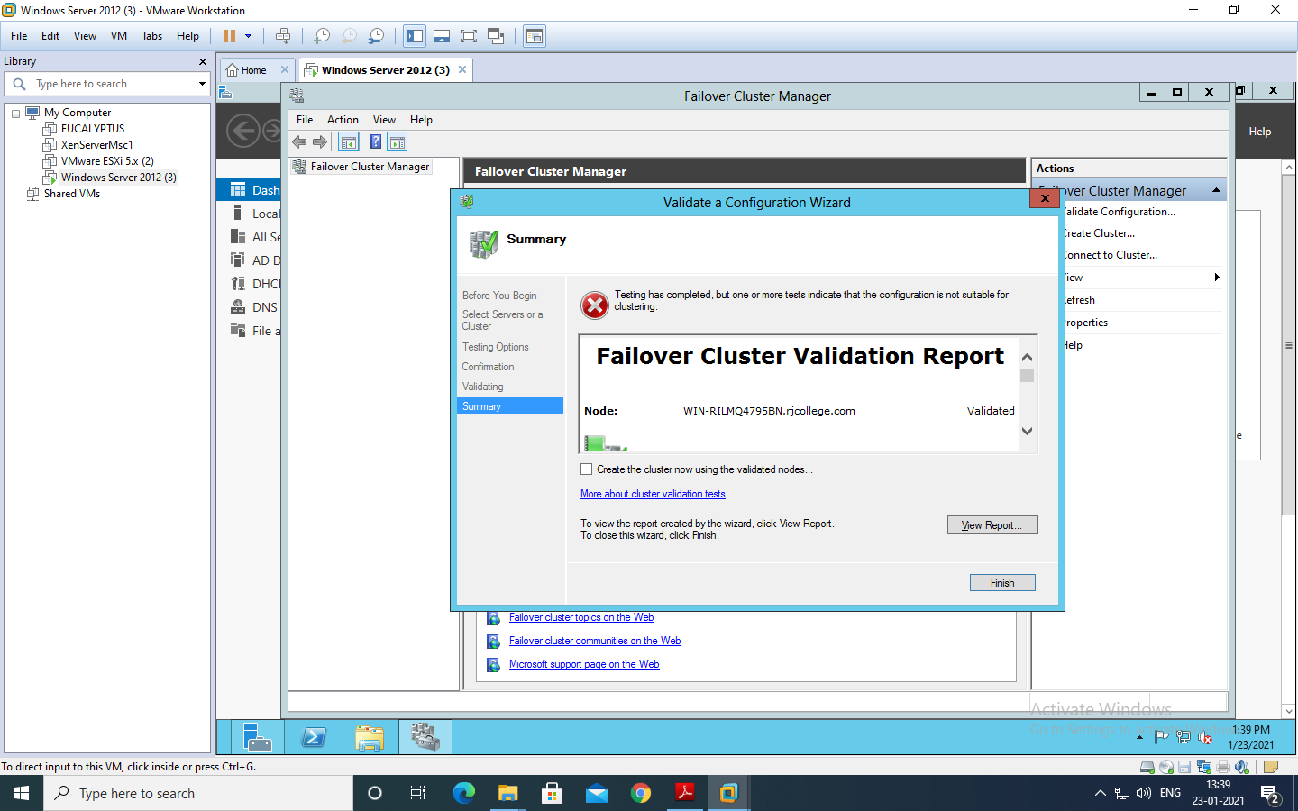

After validation completion you will create the “Create Cluster Wizard” click Next.

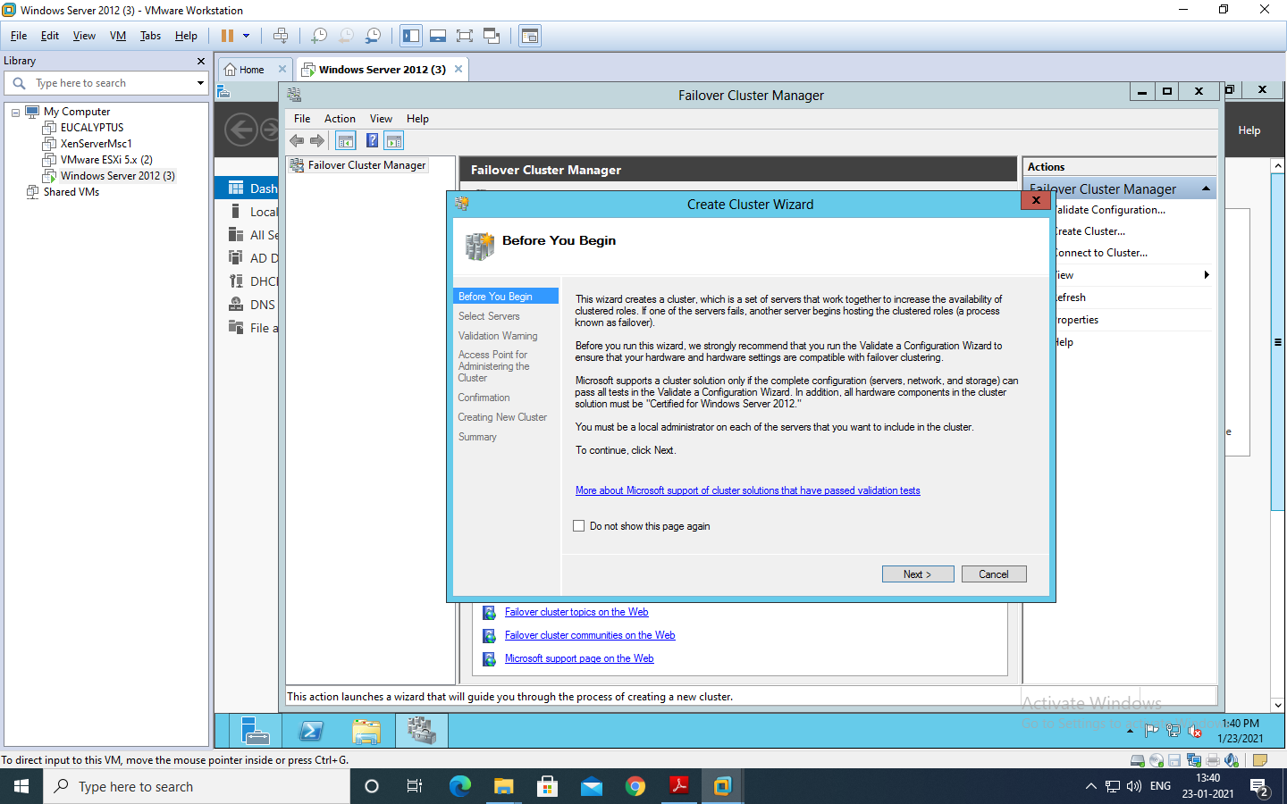

Specify the Cluster name. Cluster name here should be the NetBIOS name of the Domain Controller, so here it is RJC_Node. Click next

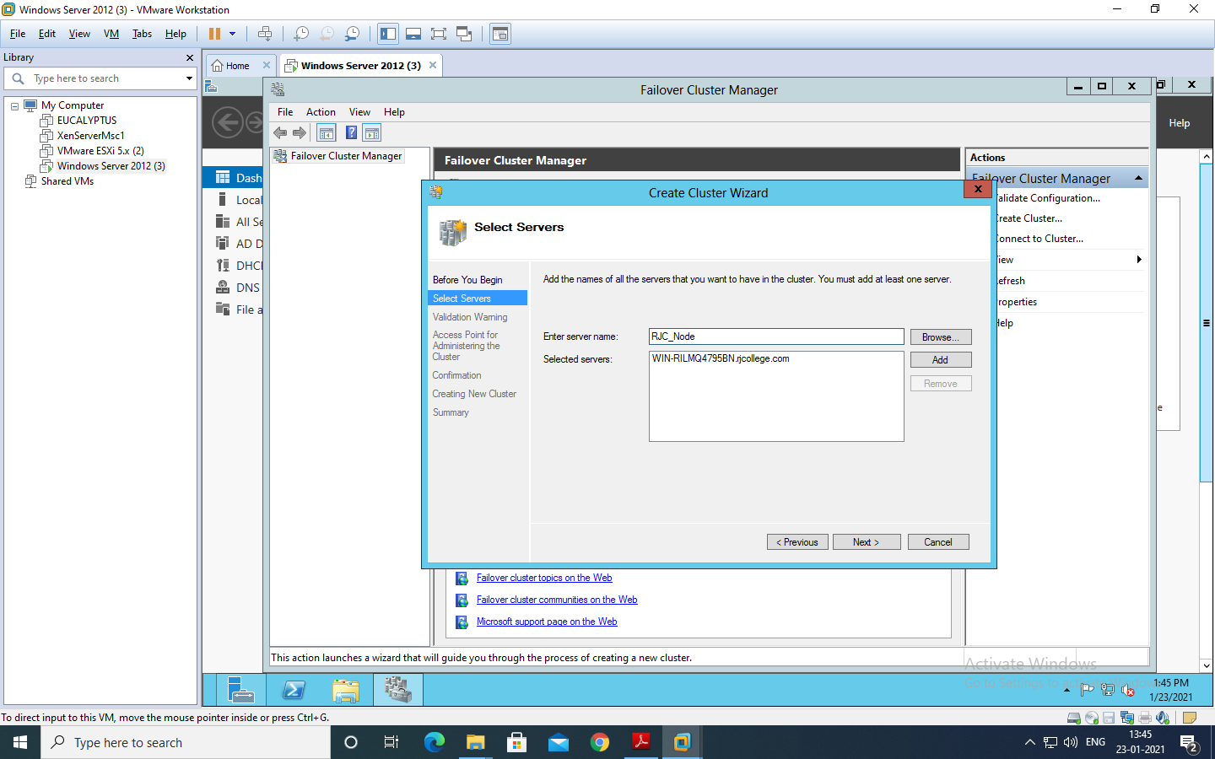

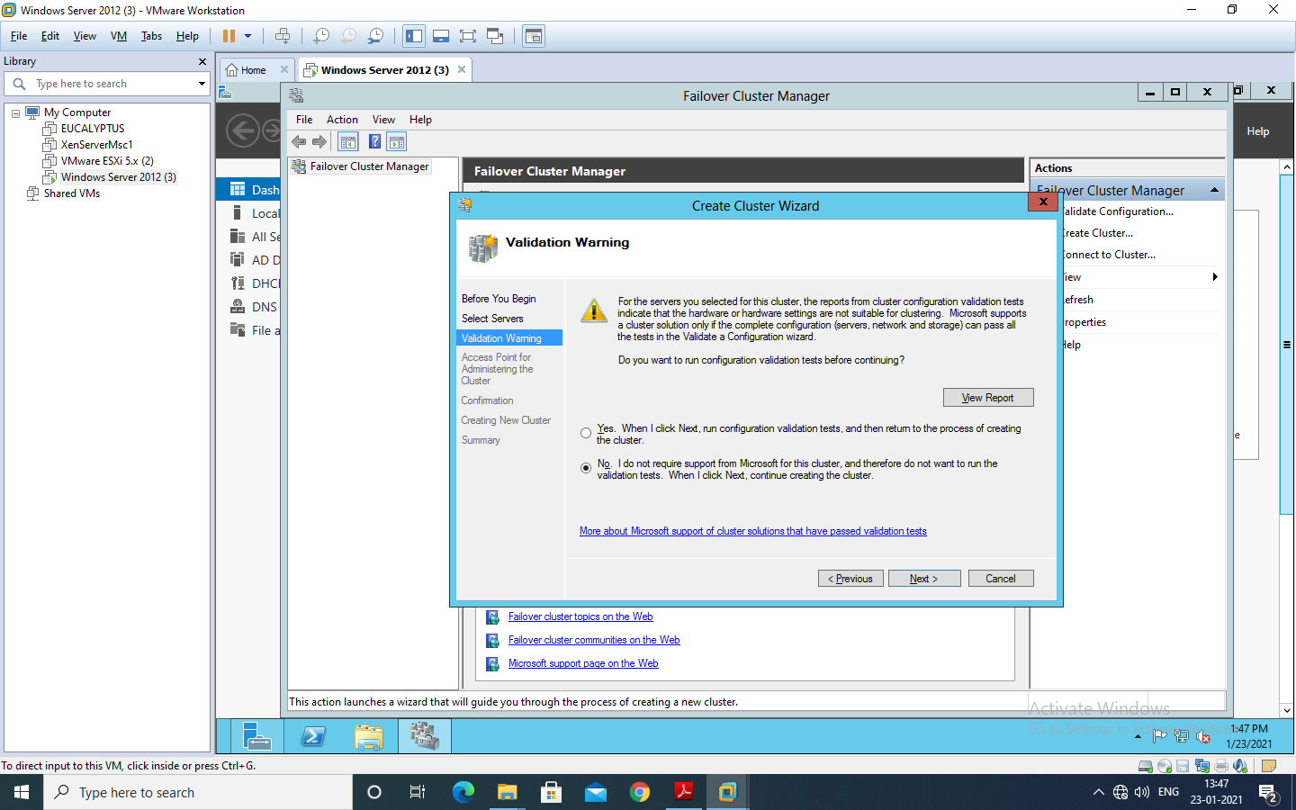

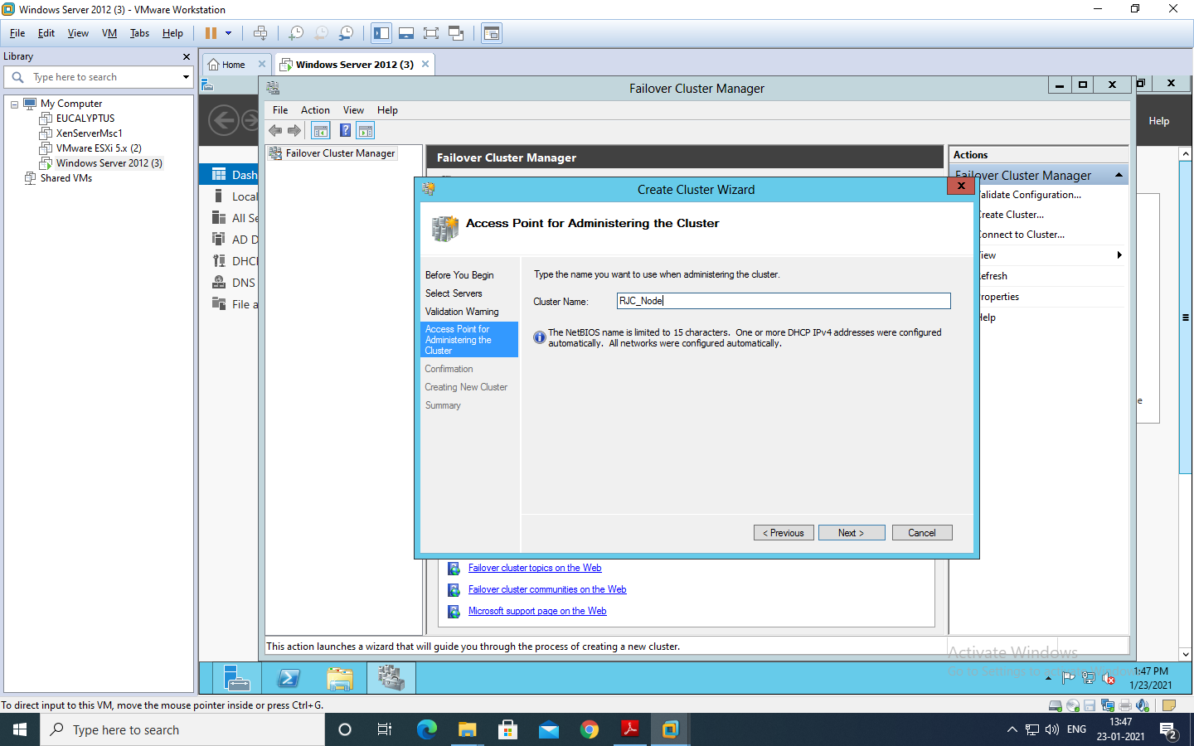

It will ask for the confirmation of cluster Creation. Click “Next”.

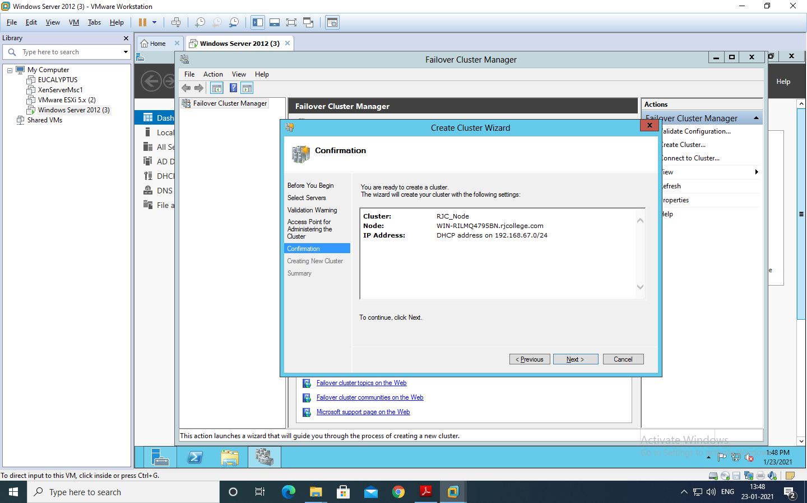

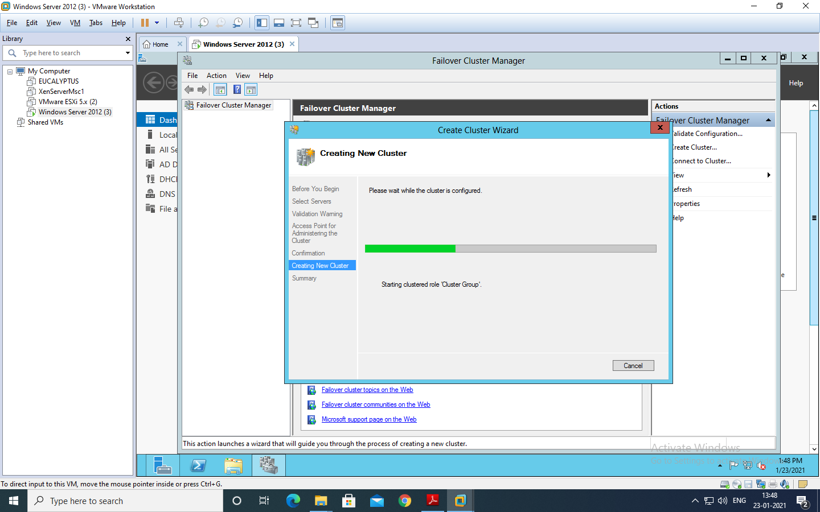

If the Cluster creation is successful you should see the following screen that shows a message “You have successfully completed the Create Cluster Wizard”.

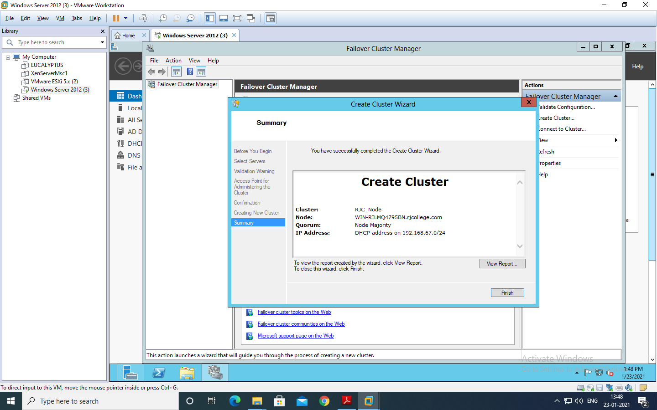

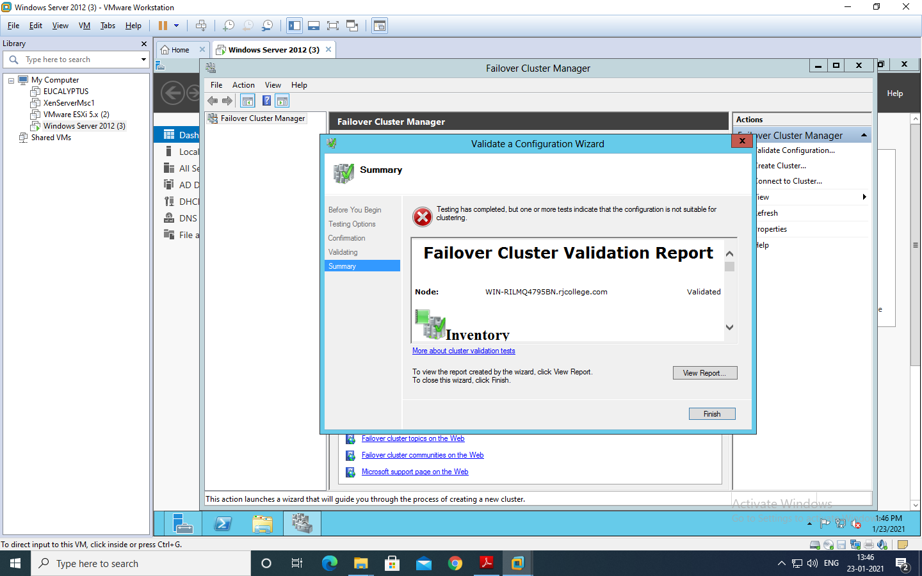

After cluster gets created you can see the cluster on the left side as shown in the screen below.

